
INSTRUCTIONS FOR USE
Simply Breathtaking
1. General Description and Use 3
2. Major Components 7
3. Indications For Use 8
4. Contraindications 9
5. Cautionary Notes 9
6. Technical Specifications 10
7. Care and Handling 11
8. Water Resistance 11
9. Breezing MedTM Status Indicators 12
10. Safe Disposal 13
11. Regulatory Statement 14
12. Copyright, Patent and Trademark Notice 15
13. Limited Warranties 15
14. Battery Charging 17
15. App Installation 17
16. Error Message/Troubleshooting 18
17. Standards 18
18. Appendix A: Summary of Information For Use 19
19. Appendix B: Breezing Med Operating Instructions 26
20. Revision History 565

General Description and Use

Breezing MedTM Metabolism Analyzer is the first wearable indirect calorimeter that is battery-operated and syncs with mobile devices for professional use. It is based on Gold-Standard indirect calorimetry, which determines a person’s energy expenditure by measuring both oxygen consumption and carbon dioxide production rates in breath.

Indirect calorimetry is well-established and widely used to measure resting energy expenditure and is recommended for the treatment of obesity and management of weight by the World Health Organization, Academy of Nutrition and Dietetics, and American College of Sports Medicine.

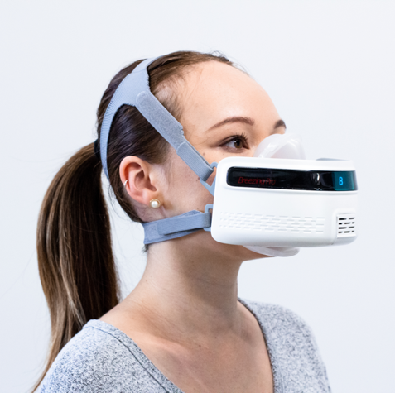
Resting energy expenditure determines what our bodies need to sustain life. For most of us who only spend 2-3 hours a week on exercise, it comprises over 75-80% of our total energy expenditure.

Everyone’s resting energy expenditure is different, depending on his/her genes, age, weight, height, body composition, etc. A person’s resting energy expenditure can also change over time. For example, building muscle can help increase resting energy expenditure, a sudden reduction in food intake can decrease resting energy expenditure, and thyroid disorders can also affect a person’s resting energy expenditure.

Breezing MedTM is paired with a mobile device via Bluetooth. A customized mobile app guides the practitioner through the resting energy expenditure measurement, allowing them to view and export the measurement results, as well as track the history of resting energy expenditure, RQ, and other parameters.

Conditions before and during the measurement

This device is not designed for use on children, unconscious patients, or for those who cannot breathe on their own or have difficulties breathing.

Ideally, the measurement should be taken first thing in the morning (overnight fasting). Otherwise, the professional should make sure the client hasn't eaten for at least 4 hours, with their most recent meal being moderate in caloric intake (~500 kCal). The professional should ask the client to avoid drinking coffee, tea, milk, or other beverages (water is fine) at least 4 hours before the measurement.

Note: If the client hasn't fasted, the professional should assess what the client has eaten/drank in the last 4 hours and determine whether there is a significant number of calories or excessive amount of caffeine intake.

The professional should also make sure the client avoids moderate exercise (i.e., jogging, Pilates) at least 4 hours before the measurement and strenuous exercise (i.e., HIIT training, long-distance running) at least 12 hours before the measurement.

The professional should make sure the client is seated for a total of 20 minutes in a quiet, comfortable (room temperature) environment before the measurement.

To ensure the client is truly at rest, the professional is recommended to assess their physiological state with a heart rate or blood pressure monitor.

The client should be seated in a comfortable position for the measurement.

The measurement

Make sure the Breezing MedTM device and mobile device (e.g. tablet) are charged, then open the app and follow the onscreen app instructions. Do not remove the sensor cartridge from the packaging until the app instructs you to insert the sensor cartridge.

- Once the client’s profile is created in the app, select “START” to start a measurement. If the client’s profile has been created before, and there are already existing measurements, select “NEW TEST”
- Turn on the device by pressing and holding the Power button (on the back) for 2 seconds.

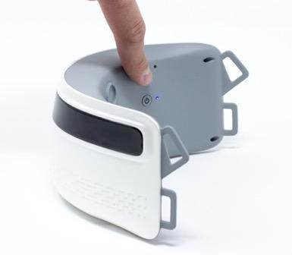
- Once the Breezing MedTM device is turned “ON”, select “CONNECT” to pair the Breezing MedTM Bluetooth to the mobile device.
- Once the Breezing MedTM Bluetooth is paired, select “SCAN” to scan the QR code located at the front of the sensor cartridge box. This allows the Breezing MedTM App to read the calibration code of the sensor cartridge.
- After scanning the QR code, make sure the sensor cartridge is correctly positioned to show the letter “B", insert it into the sensor slot, close the sensor slot with the cap, and select “CHECK SENSOR” to check the quality and position of the sensor cartridge. Please, do not attach the disposable mask yet.

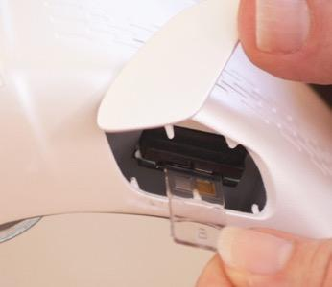
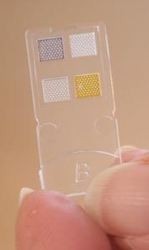

- Before attaching the disposable mask, place the Breezing MedTM device right-side up on a flat surface, select “CONTINUE”, and wait for the device to perform the self-check process.

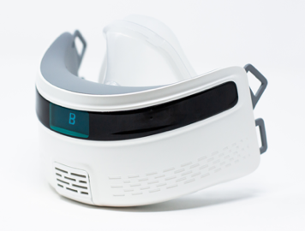
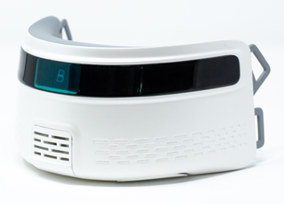

- Wait for “DEVICE SELF-CHECK” to finish.
- Attach the disposable mask and the strap to the Breezing MedTM device, then place it over the client's head. Once you ensure the strap fits properly (see section: Tips on how to avoid "leaks"), ask the clients if he/she perceives any leaks. Readjust the mask to avoid any leaks. When ready, select “START TEST” and start the measurement.

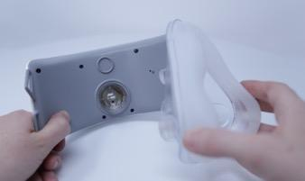
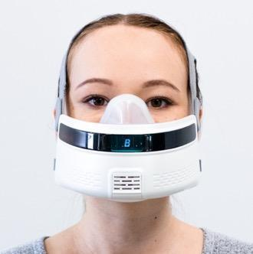

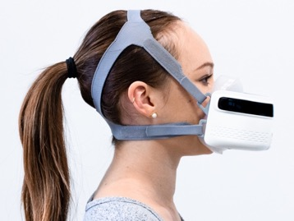
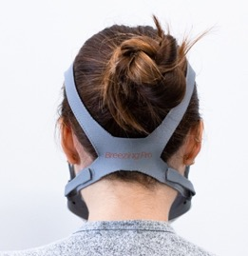

- The client should breathe naturally and maintain a neutral head position during the measurement.

Tips on how to avoid "leaks"

To avoid leaks during the measurement it is important to be familiar with the assembly of the headgear (i.e. headstrap), the disposable mask, and the device.

The professional should make sure the headgear can be securely fastened around the client's head. This means to fasten the headgear until a point it cannot be fastened any longer.

For clients with long hair and/or voluminous hair, it is recommended to tie the hair up (e.g. ponytail) to ensure a better fit of the headgear onto the head. In general, loose hair can induce mask-shifting during the measurement, causing leaks.

Once the professional has ensured the headgear fits properly (doesn’t slide around on the client’s head), she/he should ask the client if he/she perceives "leaks" (a stream of air on the face passing through the edge of the mask) and readjust the mask position as needed.

Major Components

Breezing MedTM System includes the following components: A) Breezing MedTM device, B) disposable mask, C) sensor cartridges, D) battery charger, and E) headgear, and F) Breezing MedTM mobile app.
- The Breezing MedTM device reads the optical responses of the sensor cartridge to the user’s breath, breathing flow rate and other parameters, and transmits the readings to a mobile device.
- The disposable mask connects to the Breezing MedTM device, over the client’s face and allows the client to exhale into the Breezing MedTM device. The mask is disposable.
- Sensor cartridges detect oxygen and carbon dioxide concentration in the breath when inserted into the Breezing MedTM device. A sensor cartridge is for a single measurement only and should be disposed of after each measurement.

CAUTION: To avoid contact with chemicals on the sensing area and to ensure the accuracy of the measurement, sensor cartridges should be gripped from the dedicated handle portion (marked with a “B” logo)

- The battery charger charges the battery of the Breezing MedTM device.
- The headgear allows the Breezing MedTM device and disposable mask to be worn over the client’s head. The headgear is disposable.
- The Breezing MedTM mobile app guides the measurement, displays the results, and manages the results history. It must be installed on a mobile device before the measurement.
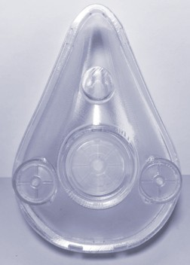
The disposable mask (reusable after cleaning and disinfection)

The professional should familiarize themselves with the disposable mask before using during the measurement. Before beginning, the professional should place the disposable mask on the client's face, without attaching it to the Breezing MedTM device and have the client breathe in and out to make sure no air leaks during the process. If a stream of air leaks through the edge of the mask, readjust the mask. This procedure will prevent potential air leaks in the mask during the actual measurement.

The disposable mask has two lateral air valves (marked with arrows), and one central air valve. The lateral valves open upon inhalation and remain closed during exhalation. The central valve opens only during exhalation.

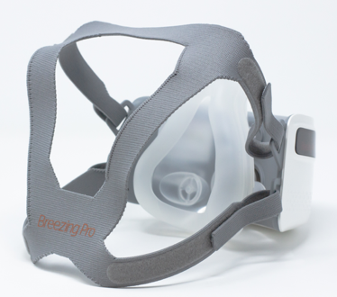
The disposable headgear (reusable after cleaning and disinfection)

The professional should be familiar with the headgear and the way it is attached to the lateral holders of the Breezing MedTM device. By attaching the headgear with the “Breezing MedTM” logo horizontally (as indicated in the picture), the professional should access the client’s head with two of the headgear’s ends open, and two headgear’s ends close for easy placement on client’s head.

Indications For Use

Breezing MedTM measures resting energy expenditure and respiratory quotient during resting conditions through direct measurement of oxygen uptake and carbon dioxide production, in order to provide nutritional assessment, to optimize nutritional supplements, and to quantify substrate utilization.

The nutritional assessment enables the healthcare professional to further assess energy expenditure and caloric intake for weight management, and to aid in the diagnosis of diseases related to abnormal metabolic parameters.

Breezing MedTM is intended for use with adults breathing normally on their own in a sitting position in a healthcare environment. Since the device is designed for the patient to breathe ambient air, it is not intended for patients where supplementary oxygen is being provided. Breezing MedTM is not intended for use as a sole means for any diagnosis, and any evaluation should ultimately be made by the professional.
Breezing MedTM is a FDA Class 2 medical device.

Contraindications

- The Breezing MedTM is not intended as a monitoring device, nor as a sole means of determining a patient's diagnosis, but for the purpose of assisting the professional.
- The device is to be used on adults only.
- The device assumes the patient is breathing ambient air and is not intended for patients who require supplementary oxygen.
- The device is not to be used if any respiratory impediments, illnesses, or chronic conditions are present.
- The device is not to be used if any infectious agents are present.

Cautionary Notes

- The Breezing MedTM sensor cartridge is a precision instrument and should only be handled by a healthcare professional. Do not allow the patient to touch or handle the sensor cartridge.
- The Breezing MedTM is intended to quantify a patient’s resting metabolic rate, but the healthcare professional should utilize their training, experience and judgment when considering the device’s results. If the healthcare professional believes the results to be inaccurate, they should use their own professional judgment to determine if a second measurement is needed.
- The Breezing MedTM is a battery-operated device. Do not attempt to operate the device when connected to the AC charging cable and adapter.
- The Breezing MedTM is intended for use in a professional and home healthcare environment. Use near surgical sites, critical care units, or magnetic imaging sites should be avoided to prevent improper functioning of the Breezing MedTM and interference with critical medical equipment.
- Use of this equipment adjacent to or stacked with other equipment should be avoided as it may result in improper operation. If such use is necessary, this device and the other equipment should be observed to verify that they are operating normally.
- The Breezing MedTM is supplied with an AC-to-USB adapter and cable. Do not use substitutes for the provided equipment. Instead, contact Breezing Co. for replacement. Use of non-authorized equipment could result in improper function, electromagnetic interference, or user harm.
- Portable RF communications equipment (such as antenna cables and external antennas) should not be used in proximity closer than 30 cm (12 inches) with any part of the Breezing MedTM, including those cables supplied by the manufacturer. Otherwise, the performance of the Breezing MedTM could be impacted.
- In the event that an electrostatic discharge has occurred, the Breezing MedTM will become inoperable. Return the device to Breezing Co. for repair.
- The Breezing MedTM is MRI unsafe.

Technical Specifications

Product Name | Breezing MedTM Metabolism Analyzer
Principle | Indirect calorimetry* (measurement of oxygen consumption and carbon dioxide production rates)
FDA Classification | Class II
Measurements
Parameters | Resting Metabolic Rate (RMR) or Resting Energy Expenditure (REE), Respiratory Quotient (RQ, or energy source as carbohydrates and fats)
Resolution Unit | 10 kCal/day for REE, RQ for energy source ranges (mostly fats, mixed, or mostly carbs)
Measurement Time | ~10 min. (Specific to individuals)
Operating Environment
Temperature Range | 59 to 86 ºF (10 to 30 ºC)
Elevation Range | 47Pa – 106kPa
RH Range | (0 – 60) % (non-condensing)
Wireless Communication
Wireless Type | Bluetooth®
Carrier Frequencies | 2.40 to 2.48 GHz
Antenna | Omnidirectional
Operating Specifications
Power Input | 3.7 V – 500 mAh
Battery Type | Lithium ion polymer (review disposal instructions below)
Battery Cycle | ~20 measurements (with fully charged battery)
Data Storage | External device with the Breezing MedTM App (mobile device), and cloud storage (after customer’s approval)
Size, Weight, and Materials
Weight | 160g
Dimensions | 16cm (width) x 8cm (height) x 11cm (depth)
Materials
Device | Makrolon Polycarbonate
Mask | Silicone Rubber
Headgear | Polyester with Spandex
Mobile Device OS:
Operating System | iOS and Android
Others
Warranty | 1 year limited
Accessories | Disposable mask, headgear, sensor cartridges (one-time use), AC-USB adapter and micro-B USB 90cm cable.
* Recommended and Preferred Method by the Academy of Nutrition and Dietetics (formerly known as American Dietetic Association): H. M. Seagle, G. W. Strain, A. Makris, and R. S. Reeves, “Position of the American Dietetic Association: Weight Management,” Journal Of The American Dietetic Association, vol. 109, pp. 330-346, 2009), and Hollie A. Raynor, PhD, RD, LDN; Catherine M. Champagne, PhD, RDN, LDN, FADA. “Position of the Academy of Nutrition and Dietetics, Journal of the American Dietetic Association, vol. 116, pp. 129, 2016.

Care and Handling

Though the Breezing MedTM is designed for durability and long-term use, it is a sensitive device. Rough handling can break internal components. Be careful not to drop or expose the device to sudden voltage, and store in a safe place when not in use. Avoid exposing Breezing MedTM and accessories to extreme temperatures, direct sunlight, moisture, sand, dust, or mechanical shock.
Periodic cleaning is required. Refer to Appendix B for instructions.

Water Resistance

Breezing MedTM is not designed for contact with liquid water, whether through cleaning or condensation.

Breezing MedTM Status Indicators

Symbol | Explanation
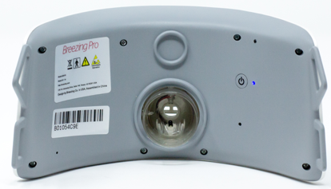 | Blue light indicator to the right of the Power button lights up when the Breezing MedTM device is ON.
 | This indicates the Breezing MedTM device’s Bluetooth® is connected to the mobile device’s Bluetooth.® This message appears before the action to “SCAN QR CODE”.
 | Low battery symbol (at the bottom of the Breezing MedTM device) lights up when battery is low, and it indicates "Low Battery" status.
 | White charging battery symbol (at the bottom of the Breezing MedTM device) lights up when the battery is being charged. The symbol disappears when fully charged.

Package Symbol Definitions
Symbol | Explanation
 | Breezing MedTM logo
 | The ETL Listed Mark is from Intertek  http://www.intertek.com/marks/etl/
 | Federal Communication Commission approved wireless communication used in the device
FCC ID: P41BTM403 | FCC ID for the Federal Communication Commission approved wireless communication module
Model: B2018 | Model of the Breezing MedTM device
Rated: 5V-1A | Electrical ratings of the device for charging
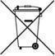 | The Breezing MedTM device must be disposed of properly and should be recycled in a safe, environmentally friendly manner. Exposing components to fire may cause an explosion. Contact your local sanitation and waste disposal organizations for information regarding proper disposal methods.  The mask, head gear, and sensor cartridge can be disposed of in normal trash.
 | Type BF device
 | Please see instructions and warnings in the manual
 | Electrostatic sensitive device
 | MRI Unsafe
Intermittent Operation | Intermittent operation, with 5-minute resting period dedicated to drying the interior parts of the device
B00784B54 (example) | Bar code with serial number

CAUTION: Medical/electrical equipment require special precautions regarding electromagnetic environments (EMC) and must be installed and put into service according to the EMC information provided in Appendix 1. Portable and mobile radio frequency (RF) communications equipment can affect medical electrical equipment.

Safe Disposal

Caution: The Breezing MedTM device contains a lithium battery, lithium-ion battery and various electronic components. These materials may pose a hazard if improperly handled. Do not attempt to open the device. Instead, dispose of the device as follows:
- Guidelines for the disposal of lithium batteries and electronics are continually under reviews. Your local regulatory agencies or waste management companies could provide
assistance in the disposal of this device.
- Disposal should be done in accordance with applicable regulations, which vary from region to region. In some areas, disposal of used batteries can be done through non-profit organizations mandated by local authorities or organized by professionals.

- The device should not be incinerated unless suitable procedures are followed and qualified handlers have taken appropriate precautions. Exposure of these batteries to high temperatures or fire can cause the cells to vent and/or rupture.

Regulatory Statement

TF Health Corporation, doing business as Breezing Co. (hereafter “Breezing Co.”), 1761W. University Dr. Suite 140, Tempe, AZ 85281, USA, declares under its sole responsibility that Breezing MedTM complies with the following standards: IEC 60601-1-2:2014, IEC 60601-1:2005Ed.3+A1, Class B for Emissions, and Immunity for not Life-Supporting Equipment. Operation is subjected to the following two conditions:
(1) This device may not cause harmful interference, and
(2) This device must accept any interference received, including interference that may cause undesired operation.

This equipment has been tested and found to comply with the limits for a Class B. These limits are designed to provide reasonable protection against harmful interference in a residential installation. This equipment generates, uses, and can radiate radio frequency energy and, if not installed and used in accordance with the instructions, may cause harmful interference to radio communications. However, there is no guarantee that interference will not occur in a particular installation. If this equipment does cause harmful interference to radio or television reception, which can be determined by turning the equipment off and on, the user is encouraged to try to correct the interference through one or more of the following measures:

- Reorient or relocate the receiving antenna.
- Increase the separation between the equipment and receiver.
- Connect the equipment into an outlet on a circuit separate from the receiver.
- Consult the dealer or an experienced radio/TV technician for help.

CAUTION: Changes or modifications to this equipment not expressly approved by the party responsible for compliance could void the user’s authority to operate the equipment. This product is a Class B complying with the specified requirements of the Standard to provide protection against electric shock, particularly regarding allowable Leakage Current.

Copyright, Patent and Trademark Notice

Breezing MedTM and/or some of its components and features are covered by granted patents and pending patent applications. The Breezing MedTM Mobile App, the software and firmware stored on the Breezing MedTM and the Breezing MedTM database (individually and collectively, the “Breezing MedTM Materials”) are protected by copyright law and/or trade secret law and may not be copied, reproduced, modified, published, distributed, transmitted, transferred, used to create derivative works or otherwise used without the expressed written permission of Breezing Co.

Breezing and Breezing MedTM logos



and other trademarks and/or names are trademarks or service marks of Breezing Co. Breezing Co.’s trademarks may not be used in connection with any product or service that is not Breezing Co.’s, in any manner that is likely to cause confusion among the general public, or in any manner that disparages or discredits Breezing Co. or its affiliates. The absence of a trademark, trade name or service mark from the above list does not constitute a waiver of Breezing Co.’s intellectual property rights concerning that trademark, trade name or service mark.

Limited Warranties

Breezing Co. warrants that its Hardware (other than the battery) is free of defects in materials and workmanship under normal use and service (the “Hardware Limited Warranty”) for 1 year from the date the product is purchased by the original retail purchaser (the “Limited Warranty Period”). Breezing Co. also warrants that it has all proprietary rights necessary to license the Breezing MedTM Materials to you and that, to the knowledge of Breezing Co., no claim has been made against Breezing Co. that any of the Breezing MedTM Materials infringes upon the proprietary rights of any third party (the “Software Limited Warranty”). The Hardware Limited Warranty and the Software Limited Warranty are only valid for the original retail purchaser and only for the Limited Warranty Period from the date of initial retail purchase of the Hardware or download of the relevant software, whichever applies.

The Hardware Limited Warranty does not apply to and expressly excludes the battery.
The Hardware Limited Warranty and the Software Limited Warranty are subject to compliance with the applicable user guides and instructions and do not apply to normal wear and tear or damage caused by improper or incorrectly performed maintenance, negligence, accident, misuse or unreasonable use, modification, tampering, or any other causes not related to design, materials or workmanship.

If a defect covered by the Hardware Limited Warranty or the Software Limited Warranty occurs during the Limited Warranty Period, Breezing Co. will, at its option, repair or replace the defective product or software or refund the original purchase price. The foregoing remedies are your sole and exclusive remedies and Breezing Co.’s sole and exclusive liability for breach of the Hardware and Software Limited Warranties. To exercise your remedy, you must provide proof of purchase, and to the extent the remedy involves return of a defective product, you will be responsible for, and must pre-pay, all return shipping charges and assume all risk of loss or damage to the product while in transit to Breezing Co. We recommend that you use a traceable method of shipping for your protection. Except as expressly set forth in this paragraph, neither Breezing Co. nor its licensors will have any obligation to furnish any maintenance and support services with respect to the product.

DISCLAIMERS; LIMITATIONS
EXCEPT AS SPECIFIED IN THE LIMITED WARRANTY SECTION ABOVE, THE BREEZING MED PRODUCTS ARE PROVIDED “AS IS” WITHOUT WARRANTY OF ANY KIND, EITHER EXPRESS OR IMPLIED, INCLUDING, BUT NOT LIMITED TO, THE IMPLIED WARRANTIES OF MERCHANTABILITY AND FITNESS FOR A PARTICULAR PURPOSE, NON-INFRINGEMENT, QUALITY, NON-INTERFERENCE, ACCURACY OR ARISING FROM A COURSE OF DEALING, PERFORMANCE, USAGE, OR TRADE PRACTICE, WHICH WARRANTIES ARE EXPRESSLY DISCLAIMED BY BREEZING CO. TO THE EXTENT ALLOWED BY APPLICABLE LAW. BREEZING CO. DOES NOT WARRANT THAT THE BREEZING MEDTM MATERIALS WILL MEET YOUR REQUIREMENTS. THE REMEDIES SET FORTH HEREIN ARE YOUR SOLE AND EXCLUSIVE REMEDIES. TO THE EXTENT AN IMPLIED WARRANTY CANNOT BE EXCLUDED, SUCH WARRANTY IS LIMITED IN DURATION TO THE LIMITED WARRANTY PERIOD. BECAUSE SOME STATES OR JURISDICTIONS DO NOT ALLOW LIMITATIONS ON HOW LONG AN IMPLIED WARRANTY LASTS, THE ABOVE LIMITATION MAY NOT APPLY. THESE WARRANTIES GIVE YOU SPECIFIC LEGAL RIGHTS, AND CUSTOMER MAY ALSO HAVE OTHER RIGHTS, WHICH VARY FROM JURISDICTION TO JURISDICTION.

In no event will Breezing Co. be liable for any ECONOMIC, INCIDENTAL, CONSEQUENTIAL, INDIRECT, SPECIAL, PUNITIVE OR EXEMPLARY DAMAGES, WHETHER CLAIMED UNDER CONTRACT, TORT OR ANY OTHER LEGAL THEORY, including but not limited to, lost profits or lost savings, even if Breezing Co. has been advised of the possibility of such damages, or for any claim by any other party. Some states do not allow the limitation or exclusion of liability for incidental or consequential damages, so the above limitation or exclusion may not apply to you.

SUBJECT TO APPLICABLE LAW, IN NO EVENT WILL BREEZING CO.’S LIABILITY EXCEED THE PURCHASE PRICE OF THE BREEZING MEDTM HARDWARE. This disclaimer and exclusion will apply even if the Limited Warranties set forth above fail of their essential purpose.

BREEZING MEDTM SYSTEM IS FOR PROFESSIONAL USE ONLY.

Breezing MedTM is designed to provide information on resting energy expenditure, and associated measurement parameters. However, Breezing Co. has no control over, and makes no representations or warranties, expressed or implied, regarding any use by you or your healthcare provider(s) of Breezing MedTM or the use or interpretation of any information stored on, generated by or received through Breezing MedTM system. A professional user is solely responsible for communicating any resting energy expenditure-related information to (and receiving feedback from) other professional certified healthcare provider(s).

The professional user is solely responsible for reviewing and evaluating the accuracy and relevance of any information stored on, generated by or received through Breezing MedTM. Breezing Co. cannot and does not guarantee such accuracy. BREEZING MEDTM AND ANY INFORMATION STORED ON, GENERATED BY OR RECEIVED THROUGH THE PRODUCT ARE NOT INTENDED TO BE A SUBSTITUTE FOR PROFESSIONAL MEDICAL ADVICE, DIAGNOSIS, OR TREATMENT. ONLY A PHYSICIAN OR OTHER QUALIFIED HEALTHCARE PROVIDER CAN ANSWER ANY QUESTIONS REGARDING A MEDICAL CONDITION.

Breezing MedTM (i) is supported by third-party databases, including, for example, data from the Compendium of Physical Activities; and/or (ii) may utilize content provided by other third-party applications or databases. Breezing Co. is not responsible for the accuracy or content of such third-party applications and database information.

Battery Charging

Note: Breezing MedTM device is battery-powered only and must be charged before use.

To charge the battery, plug the power adapter into an electrical outlet. The white battery charging symbol on the Breezing MedTM device will turn on to indicate the charging process. Once the battery is fully charged, the white battery symbol will turn off.

*WARNING: If the Breezing MedTM Metabolism Analyzer becomes non-operational due to ElectroStatic Discharge (ESD), it should be returned to the manufacturer.

App Installation

To install the Breezing App, go to Apple Store or Google Play Store

Error Message/Troubleshooting

It takes longer than 10 minutes to complete a resting energy expenditure measurement.
Action: Check that the Bluetooth® signal has not been interrupted. Check that the battery is not low.

Device does not sync with the installed app.
Action: Sign out and close Breezing App. Turn off Breezing MedTM device. Then turn it on again. Apply a long press (2-3 seconds to turn OFF and ON).

If that does not work, make sure both Breezing MedTM device and mobile device are fully charged.

Water (saliva) gets inside the device.
Action: Sign out and close the App window. Turn off Breezing MedTM device. Remove the disposable mask. Place the disposable mask on a clean surface and let the Breezing MedTM device dry. Wait 3-5 hours (depending on environmental humidity) to let the device dry up, before inserting the disposable mask and sensor cartridge to try the measurement again.
Export file will not download.
The export email with its link will be received but some browsers will block pop-ups and prevent the download of the CSV export file. Either use a different browser or disable (i.e. whitelist) the site from which the download is generated.

Breezing Co. Team is committed to providing full support to Breezing MedTM device users. Please email us at support@breezing.com any additional troubleshooting, questions, concerns, or suggestions.

Standards
The following standards have been applied to Breezing MedTM:
IEC 60601-1:2005Ed.3+A1 Medical Electrical Equipment - Part 1: General Requirements For Basic Safety & Essential Performance

IEC 60601-1-2 Edition 4.0 2014-02 Medical electrical equipment - Part 1-2: General requirements for basic safety and essential performance - Collateral Standard: Electromagnetic disturbances - Requirements and tests

Appendix A: Summary of Information For Use

Battery
Battery charging | Class II | The specification applies when the device is charging
Part | Type BF applied part
Battery charger | Input: 100 - 240 VAC, 0.5 A MAX, 50/60 Hz  Output: 5.0V, 1.0A | Use only the Breezing MedTM charger shipped with the product. Unauthorized charger can potentially damage, degrade, or put the device and/or user at risk including fire hazard and/or electric shocks.
Product Materials
Device Body: Polycarbonate
Mask: Silicone and polypropylene
Headgear: Nylon
Use
Device operation mode | Intermittent operation | Minutes between measurements
Control Functions | Breezing MedTM device: Switch button | Turns on/off of Breezing MedTM device
 | Synchronized App: Start Test Function | Allows Bluetooth® connection and enables data transmission between Breezing MedTM device and user’s mobile device
Display and indicators Functions | Breezing MedTM Device Display: (1) turning ON/OFF, (2) Battery charging, and (3) Low battery symbol  (4) REE result | The symbols turn on to indicate: (1) turning ON/OFF, (2) active battery charging (when charger is connected), (3) low battery status, (4) measured REE results after the measurement
App | Synchronized App: (1) Measurement, (2) Results, and (3) History | The screens provide: (1) Instructions to set the measurement, and time to finish the measurement, (2) list of results (including indirect calorimetry results), and related parameters, (3) interface to results’ history
Signal Functions | Synchronized App: remaining time to finish the measurement | The signal is displayed as a countdown time
Sequence of Operation | 1) The user synchronizes Breezing MedTM device with the App in a mobile device, 2) The user follows instructions in the App measurement screen, the user performs the measurement, and 3) The user reviews results, and decides to share results | Graphics examples are shown in mobile App stores (Apple store/ Google store)
Connection and disconnection of detachable parts | Detachable parts include a disposable mask, headbgear and a sensor cartridge | All parts may be attached and detached minimal applied pressure.
Replacement of material during operation | The disposable mask, headgear, and sensor cartridge are single-use. | Due to proper hygienic practices, replace the mask and sensor cartridge after each measurement.
Potential Electromagnetic and Interference Avoidance
Electromagnetic avoidance | Breezing MedTM uses Bluetooth® radiofrequency (RF) for wireless communications. The intensity of RF energy emissions is very low, and not likely to produce any interference in other electronic equipment | Electromagnetic interference should be avoided by maintaining a minimum distance between other electronic equipment and the Breezing MedTM device, and/or the mobile device with Breezing MedTM mobile App
Other interference avoidance | Other interference may be found in locations different from typical domestic, regular business, and public environments.
Maintenance
Device maintenance | The Instructions For Use should be sufficient for adequate maintenance of Breezing MedTM device. There are no other user serviceable components other than the ones indicated in this owner’s manual. | In the exceptional case that saliva reaches inner part(s) of Breezing MedTM device, the device tubing should be wiped gently to clean from dust and regular handling, dried out, and enough time should be allowed for the device to dry out (alcohol swab can be used for efficient cleaning)
Battery maintenance | Regular charging and changing the cycle of use will improve battery’s performance and longevity. | Warning: attempted replacement by unauthorized personnel could result in a hazard. Return the device to Breezing Co. for repair or replacement.
Cleaning and Disinfection
Cleaning | The device can be cleaned using the procedure in Appendix C
Disinfection | The device can be disinfected using the procedure in Appendix C | Disposal of sensor, headgear, and mask should be practiced for each measurement
Operational Environmental Conditions for Safe Use
Temperature | 59º to 86º F (10º to 30º C) | Extreme temperatures outside the specified range should be avoided
Humidity | (0 – 60) % (non-condensing) | Extreme environmental and relative humidity conditions outside the specified range should be avoided
Transport and Storage
Transport | Strong mechanical impact should be avoided when transporting Breezing MedTM device and its consumables
Storage | Breezing MedTM | -5º - +25º C  60 +/- 25% RH
 | Sensor cartridges | -5º - +25º C  60 +/- 25% RH
Disposal
Waste management | Disposal of Breezing MedTM device should be done in a designated collection point for waste recycling of electrical, electronic, and plastic equipment.  Disposal of the mask, gearhead and sensor cartridge can be made in normal trash. | Safe disposal will help conserve the environment and its natural resources. More information on where to drop your waste can be found at local recycling programs, household waste disposal services, or the Breezing Co. (see contact info below).
Minimizing risk | If the user is unsure of how to dispose of the product and consumables, contact Breezing Co. | Breezing Co. will provide adequate guidance and actions for safe disposal.
Help and Repair Information
Contact information | Email: info@breezing.com  Breezing Co.  1761 W. University Dr., Suite 140, Tempe, AZ 85281, USA | The address is provided to ship Breezing Co. products for recycling.

Guidance and Manufacturer’s Declaration - Valid for: PROFESSIONAL HEALTHCARE ENVIRONMENT
Guidance and manufacturer’s declaration – electromagnetic emissions
Breezing MedTM Metabolism Analyzer is intended for use in the electromagnetic environment specified below.
The customer or the user of Breezing MedTM Metabolism Analyzer should assure that it is used in such an environment.
Emissions Test | Compliance
RF emissions  CISPR 11 | Group 1 | Breezing MedTM Metabolism Analyzer uses RF energy only for its internal function. Therefore, its RF emissions are very low and are not likely to cause any interference in nearby electronic equipment.
RF emissions  CISPR 11 | Class A | Breezing MedTM Metabolism Analyzer is suitable for use in all establishments other than domestic and those directly connected to the public low-voltage power supply network that supplies buildings used for domestic purposes.
Harmonic emissions  IEC 61000-3-2 | Class A
Voltage Fluctuations/  Flicker emissions | Complies
Valid for: PROFESSIONAL HEALTHCARE ENVIRONMENT

Guidance and manufacturer’s declaration – electromagnetic immunity
Breezing MedTM Metabolism Analyzer is intended for use in the electromagnetic environment specified below. The customer or the user of Breezing MedTM Metabolism Analyzer should assure that it is used in such an environment.
Immunity test | IEC 60601  test level | Compliance level | Electromagnetic environment –  guidance
Electrostatic  discharge (ESD)  IEC 61000-4-2  Analyzing mode while on Battery power | ±8 kV contact  ±15 kV air | ±8 kV contact  ±15 kV air | Floors should be wood, concrete or  ceramic tile. If floors are covered with  synthetic material, the relative humidity  should be at least 30 %.
Electrostatic  discharge (ESD)  IEC 61000-4-2  Battery Charging mode | ±8 kV contact  ±8 kV air  ±15 kV air | ±8 kV contact  ±8 kV air  ±15 kV air* | Floors should be wood, concrete or  ceramic tile. If floors are covered with  synthetic material, the relative humidity  should be at least 30 %.  *WARNING: If the Breezing MedTM Metabolism Analyzer is exposed to ESD in Battery Charging mode, it may become non-operational and must be returned to the manufacturer.
Electrical fast  transient/burst  IEC 61000-4-4 | ±2 kV for power  supply lines  ±1 kV for input/output  lines | ±2 kV for power  supply lines  ±1 kV for input/output  lines | Mains power quality should be that of a  typical commercial or hospital  environment.
Surge  IEC 61000-4-5 | ±1 kV differential  mode  ±2 kV common mode | ±1 kV differential  mode  ±2 kV common mode | Mains power quality should be that of a  typical commercial or hospital  environment.
Voltage dips, short  interruptions and  voltage variations  on power supply  input lines  IEC 61000-4-11 | Voltage Dips 30% reduction, 25/30 periods  At 0° | Voltage Dips 30% reduction, 25/30 periods  At 0° | Mains power quality should be that of a  typical commercial or hospital  environment.
 | Voltage Dips > 95% reduction, 0.5 period  At 0°, 45°, 90°, 135°, 180°, 225°, 270° and 315° | Voltage Dips > 95% reduction, 0.5 period  At 0°, 45°, 90°, 135°, 180°, 225°, 270° and 315°
 | Voltage Dips > 95% reduction, 1 period At 0° | Voltage Dips > 95% reduction, 1 period At 0°
 | Voltage Interruptions > 95% reduction, 250/300 periods | Voltage Interruptions > 95% reduction, 250/300 periods
(50/60 Hz)  magnetic field  IEC 61000-4-8 | 30 A/m | 30 A/m | Power frequency magnetic fields  should be at levels characteristic of a  typical location in a typical commercial  or hospital environment.

Valid for: 3V for 150 kHz to 80 MHz; 3V for 80 MHz to 2700 MHz
PROFESSIONAL HEALTHCARE ENVIRONMENT
Guidance and manufacturer’s declaration – electromagnetic immunity
Breezing MedTM Metabolism Analyzer is intended for use in the electromagnetic environment specified below. The customer or the user of Breezing MedTM Metabolism Analyzer should assure that it is used in such an environment.
Immunity test | IEC 60601  test level | Compliance level | Electromagnetic environment –  guidance
Conducted RF  IEC 61000-4-6  Radiated RF  IEC 61000-4-3 | 3 Vrms  150 kHz to 80 MHz  (6 Vrms in ISM radio Bands within 150kHz – 80MHz)  3 V/m  80 MHz to 2.7 GHz | 3 Vrms  3 V/m | Portable and mobile RF communications equipment should be used no closer to any part of Breezing MedTM Metabolism Analyzer, including cables, than the recommended separation distance calculated from the equation applicable to the frequency of the transmitter.  Recommended separation distance  d = 1.2√P  d = 1.2√P 80 MHz to 800 MHz  d = 2.3√P 800 MHz to 2.7 GHz  where P is the maximum output power rating of the transmitter in watts (W) according to the transmitter manufacturer and d is the recommended separation distance in metres (m).  Field strengths from fixed RF transmitters, as determined by an electromagnetic site surveyª, should be less than the compliance level in each frequency range.^{b}
NOTE 1: At 80 MHz and 800 MHz, the higher frequency range applies.
NOTE 2: These guidelines may not apply in all situations. Electromagnetic propagation is affected by absorption and reflection from structures, objects and people.
ª Field strengths from fixed transmitters, such as base stations for radio (cellular/cordless) telephones and land
mobile radios, amateur radio, AM and FM radio broadcast and TV broadcast cannot be predicted theoretically with accuracy. To assess the electromagnetic environment due to fixed RF transmitters, an electromagnetic site
survey should be considered. If the measured field strength in the location in which Breezing MedTM Metabolism Analyzer is used exceeds the applicable RF compliance level above, Breezing MedTM Metabolism Analyzer should be observed to verify normal operation. If abnormal performance is observed, additional measures may be necessary, such as reorienting or relocating Breezing MedTM Metabolism Analyzer.
^{b} Over the frequency range 150 kHz to 80 MHz, field strengths should be less than 3 V/m.

Valid for: 3V for 150 kHz to 80 MHz; 3V for 80 MHz to 2700 MHz
PROFESSIONAL HEALTHCARE ENVIRONMENT
Recommended separation distances between
portable and mobile RF communications equipment and Breezing MedTM Metabolism Analyzer
Breezing MedTM Metabolism Analyzer is intended for use in an electromagnetic environment in which radiated RF disturbances are controlled. The customer or the user of Breezing MedTM Metabolism Analyzer can help prevent electromagnetic interference by maintaining a minimum distance between portable and mobile RF communications equipment (transmitters) and Breezing MedTM Metabolism Analyzer as recommended below, according to the maximum output power of the communications
equipment.
Rated maximum output power  of transmitter  W | Separation distance according to frequency of transmitter  m
 | 150 kHz to 80 MHz  d = 1.2√P | 80 MHz to 800 MHz  d = 1.2√P | 800 MHz to 2.7 GHz  d = 2.3√P
0.01 | 0.12 | 0.12 | 0.23
0.1 | 0.38 | 0.38 | 0.73
1 | 1.2 | 1.2 | 2.3
10 | 3.8 | 3.8 | 7.3
100 | 12 | 12 | 23
For transmitters rated at a maximum output power not listed above, the recommended separation distance d in
meters (m) can be estimated using the equation applicable to the frequency of the transmitter, where P is the
maximum output power rating of the transmitter in watts (W) according to the transmitter manufacturer.
NOTE 1: At 80 MHz and 800 MHz, the separation distance for the higher frequency range applies.
NOTE 2: These guidelines may not apply in all situations. Electromagnetic propagation is affected by absorption and reflection from structures, objects and people.

Valid for: PROFESSIONAL HEALTHCARE FACILITY and HOME HEALTHCARE ENVIRONMENT

Immunity to RF Wireless Communications Equipment
Test  Frequency  (MHz) | Band ^{a)}  (MHz) | Service ^{a)} | Modulation ^{b)} | Maximum  Power  (W) | Distance  (m) | IMMUNITY  TEST LEVEL  (V/m)
385 | 380 –390 | TETRA 400 | Pulse  modulation ^{b)}  18 Hz | 1.8 | 0.3 | 27
450 | 430 – 470 | GMRS 460,  FRS 460 | FM ^{c)}  ± 5 kHz deviation  1 kHz sine | 2 | 0.3 | 28
710 | 704 – 787 | LTE Band 13, 17 | Pulse  modulation ^{b)}  217 Hz | 0.2 | 0.3 | 9
745
780
810 | 800 – 960 | GSM 800/900,  TETRA 800,  iDEN 820,  CDMA 850,  LTE Band 5 | Pulse  modulation ^{b)}  18 Hz | 2 | 0.3 | 28
870
930
1720 | 1 700 –  1 990 | GSM 1800;  CDMA 1900;  GSM 1900;  DECT;  LTE Band 1, 3,  4, 25; UMTS | Pulse  modulation ^{b)}  217 Hz | 2 | 0.3 | 28
1845
1970
2450 | 2 400 –  2 570 | Bluetooth,  WLAN,  802.11 b/g/n,  RFID 2450,  LTE Band 7 | Pulse  modulation ^{b)}  217 Hz | 2 | 0.3 | 28
5240 | 5 100 –  5 800 | WLAN 802.11  a/n | Pulse  modulation ^{b)}  217 Hz | 0.2 | 0.3 | 9
5500
5785
a) For some services, only the uplink frequencies are included.
b) The carrier shall be modulated using a 50 % duty cycle square wave signal.
c) As an alternative to FM modulation, 50 % pulse modulation at 18 Hz may be used because while it does not represent actual modulation, it represents the worst case scenario.

Appendix B: Breezing Med Operating Instructions
General Description and Use

Breezing MedTM Metabolism Analyzer is the first wearable indirect calorimeter that is battery-operated and syncs with mobile devices for professional use anywhere and anytime. It is based on the Gold Standard indirect calorimetry, which determines a person’s energy expenditure by measuring both oxygen consumption and carbon dioxide production rates in breath.

Indirect calorimetry is well-established and widely used to measure resting energy expenditure and is recommended for the treatment of obesity and management of weight by the World Health Organization, Academy of Nutrition and Dietetics, and American College of Sports Medicine.

Resting energy expenditure determines what our bodies need to sustain life. For most of us who only spend 2-3 hours a week on exercise, it contributes over 75-80% of our total energy expenditure.

Everyone’s resting energy expenditure is different, depending on his/her genes, age, weight, height, body composition, etc. A person’s resting energy expenditure can change over time. For example, building muscle can help increase resting energy expenditure, a sudden reduction in food intake can decrease resting energy expenditure, and thyroid disorders can also affect a person’s resting energy expenditure.

Breezing MedTM is paired with a mobile device via Bluetooth. A customized App running in the mobile device guides the practitioner to perform the resting energy expenditure test, to view and export the test results, as well as track the history of resting energy expenditure, RQ, and other parameters measured during the test.

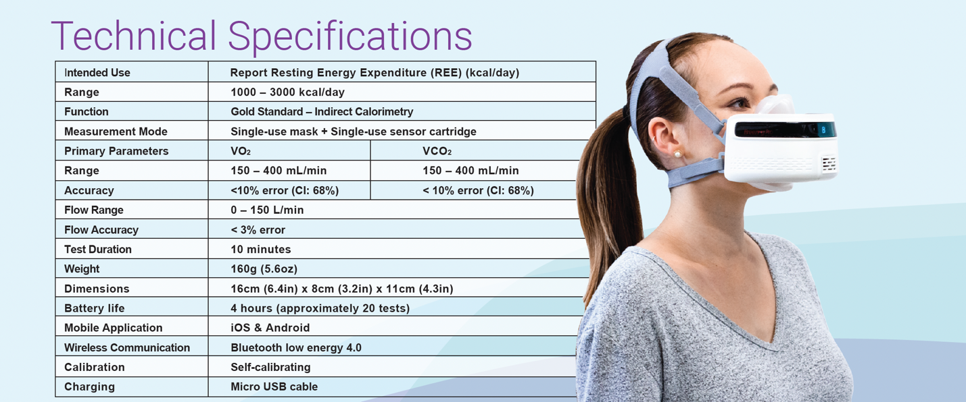
Conditions before and during the measurement

This device is not designed for use on children, unconscious patients, or for those who cannot breathe on their own or have difficulties breathing. Ideally, the measurement should be taken first thing in the morning (overnight fasting). Otherwise, the professional should make sure the client hasn't eaten for at least 4 hours, with their most recent meal being moderate in caloric intake (~500 kCal).

The professional should ask the client to avoid drinking coffee, tea, milk, or other beverages (water is fine) at least 4 hours before the test.
Note: If the client hasn't fasted, the professional should assess what the client has eaten/drank in the last 4 hours and determine whether there is a significant number of calories or excessive amount of caffeine intake.

The professional should also make sure the client avoids moderate exercise (i.e., jogging, Pilates) at least 4 hours before the measurement and strenuous exercise (i.e., HIIT training, long-distance running) at least 12 hours before the measurement.

The professional should make sure the client is seated for several a total of 20 minutes in a quiet, comfortable environment (room temperature) before the measurement.

To ensure the client is truly at rest, the professional might assess their physiological state with a heart rate or blood pressure monitor.

The client should be seated in a comfortable position for the measurement.

The measurement
Make sure the Breezing MedTM device and mobile device (e.g. tablet) are charged, run the app, and follow the instructions on the screen promoted by the app.

Do not remove the sensor cartridge from the packaging until the app instructs you to insert the sensor cartridge.
- Once the client’s profile is created in the app, select “NEW TEST”, confirm patient information, then press “START”.
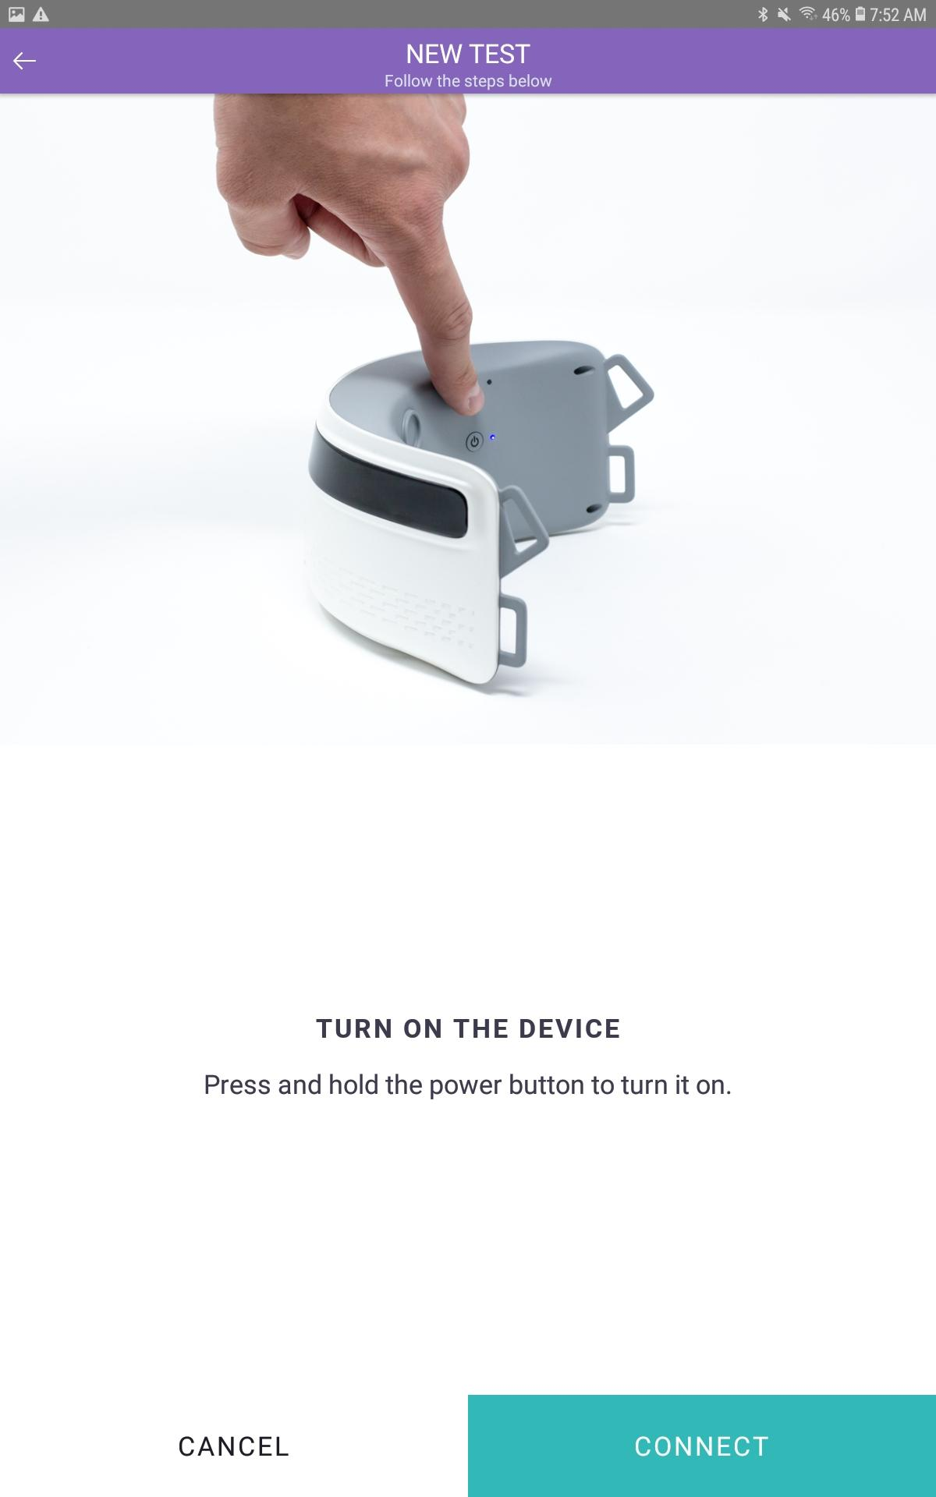
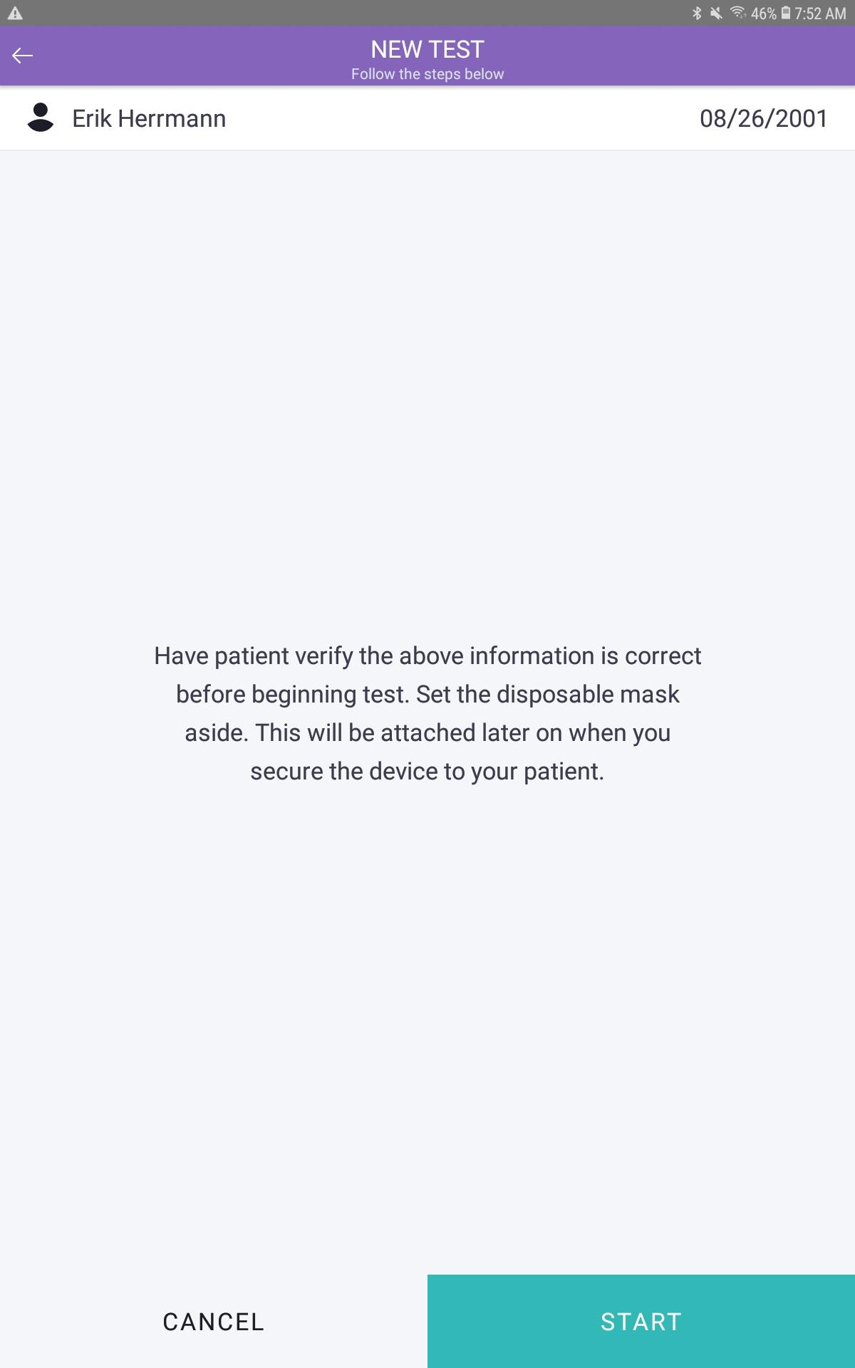
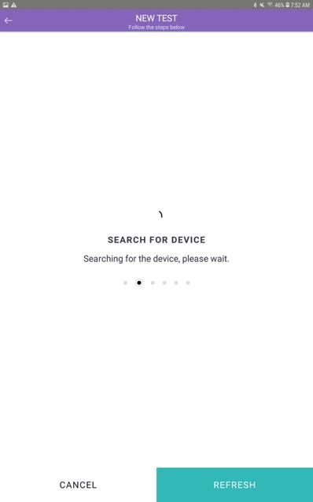
- Turn on the device by pressing and holding the Power button (on the back) for 2 seconds. Once the Breezing MedTM device is turned “ON”, select “CONNECT” to pair the Breezing MedTM Bluetooth to the mobile device, and wait for confirmation the Breezing MedTM is connected.

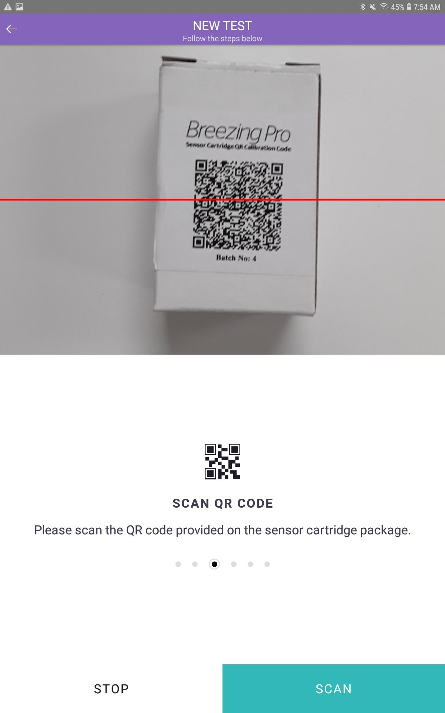
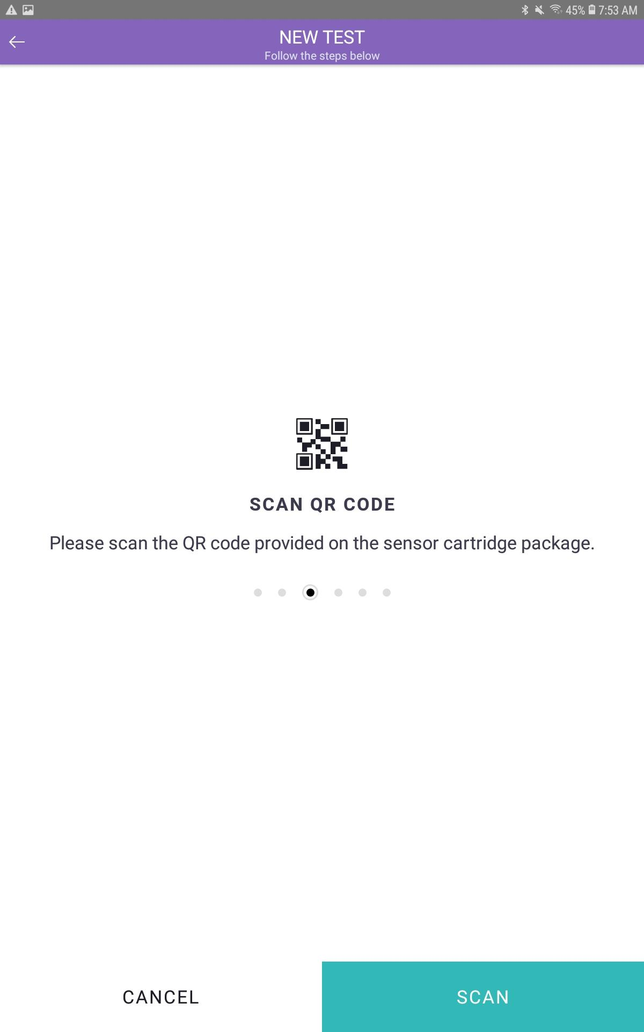
- Once the Breezing MedTM is paired, select “SCAN” to scan the QR code in the front of the sensor cartridge box to read the calibration code of the sensor cartridge into the Breezing MedTM App.
- After scanning the QR code, without attaching the disposable mask and making sure the sensor cartridge is correctly positioned to show the letter “B", insert it into the sensor slot, close the sensor slot with the cap, and select “CHECK SENSOR” to check the quality and position of the sensor cartridge.
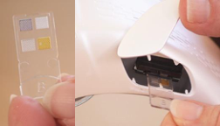
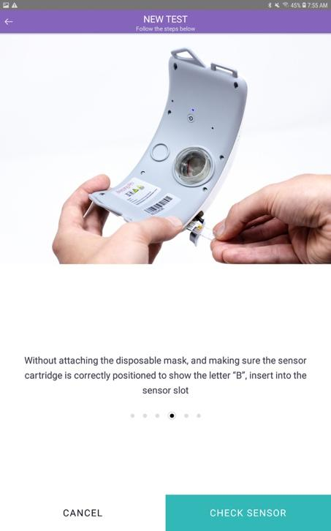
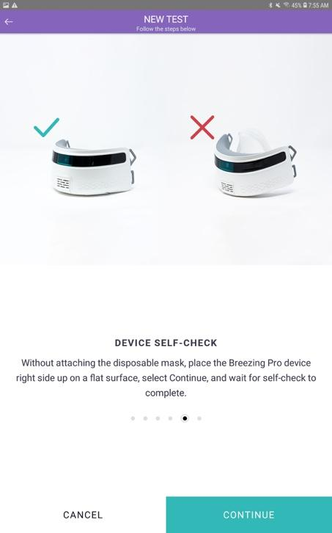
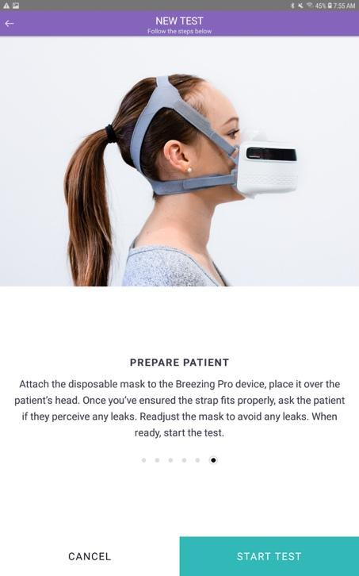
- Without attaching the disposable mask, place the Breezing MedTM device right side up on a flat surface, select “CONTINUE”, and wait for the device to perform the self-check process.
Wait for “DEVICE SELF-CHECK” to finish. “
X Incorrect position
- Attach the disposable mask and the headgear to the Breezing MedTM device, place it over the client's head. Once you ensure the headgear fits properly (see section: Tips on how to avoid "leaks"), ask the clients if he/she perceives any leaks. Readjust the mask to avoid any leaks. When ready, select “START TEST” and start the measurement.
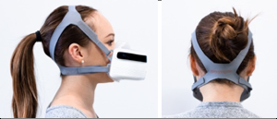
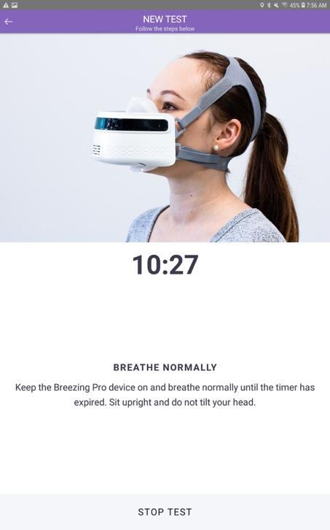
- The client should breathe naturally and keep their head straight during the measurement.

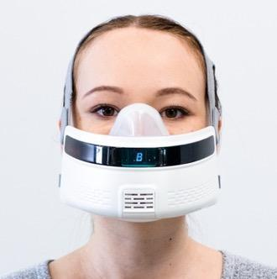

Save the results
After taking a measurement, select “Done” to save the results in the application.

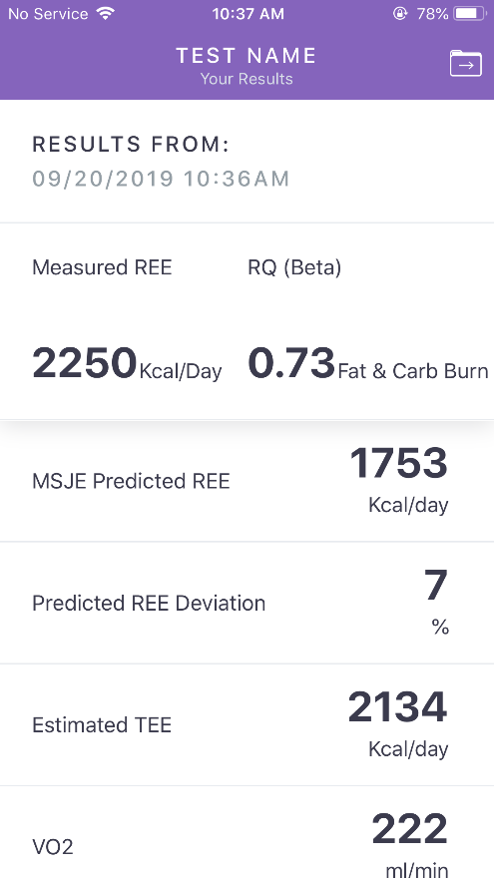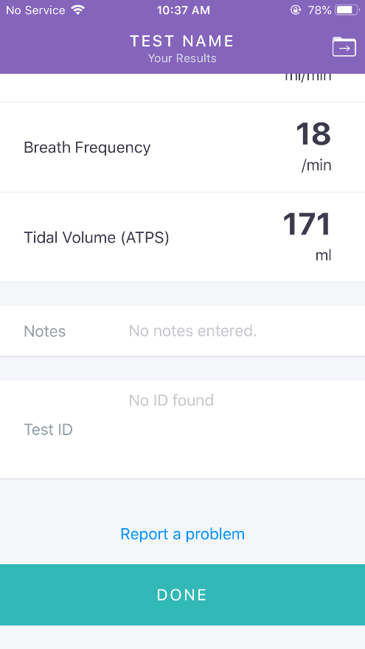

The user can also export the results to a desired destination by selecting the “Export icon” from the top right corner of the screen.

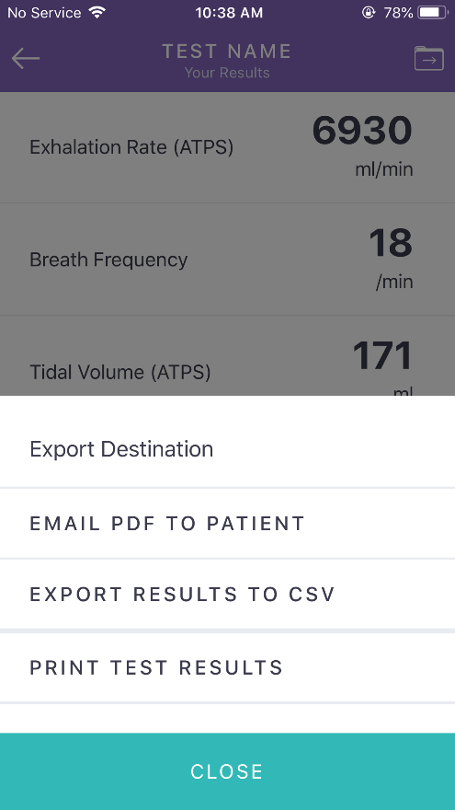

Tips on how to avoid "leaks"

To avoid leaks during the test it is important to be familiar with the assembly of the headgear, the disposable mask, and the device.
The professional should make sure the headgear can be securely fastened around the client's head. This means to fasten the headgear until a point it cannot be fastened any longer.

For clients with long hair and/or bulky hear, it is recommended to tie the hair up (e.g. ponytail) to ensure a better fit of the headgear onto the head. In general, bulky loose hair can induce mask shifting during the test, which can create leaks.

Once the professionals have ensured the headgear fits properly (doesn’t slide around on the client’s head), she/he should ask the client if he/she perceives "leaks" (stream of air on the face passing through the edge of the mask) and readjust the mask position as needed to avoid any leaks.

APP INSTALLATION:
- Download Breezing ProTM App from the Apple® App Store® (for devices compatible with iOS) or GoogleTM Play Store (for devices compatible with AndroidTM).
- Look for the following icon while searching for the application.

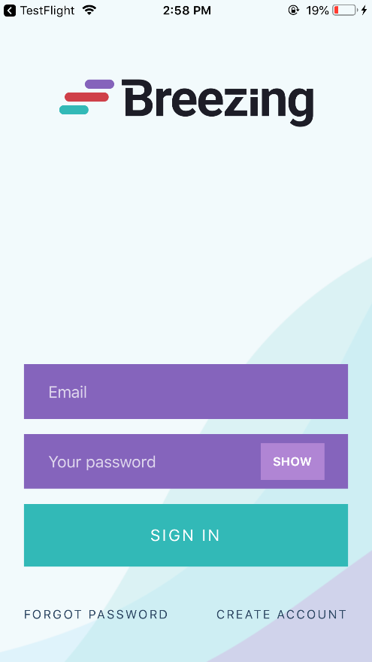
- After successful installation, the following information will be displayed on the screen once the user opens the application.
CREATE A NEW ACCOUNT:
For a new user, the user needs to register by selecting “Create Account” option and enter the corresponding information.

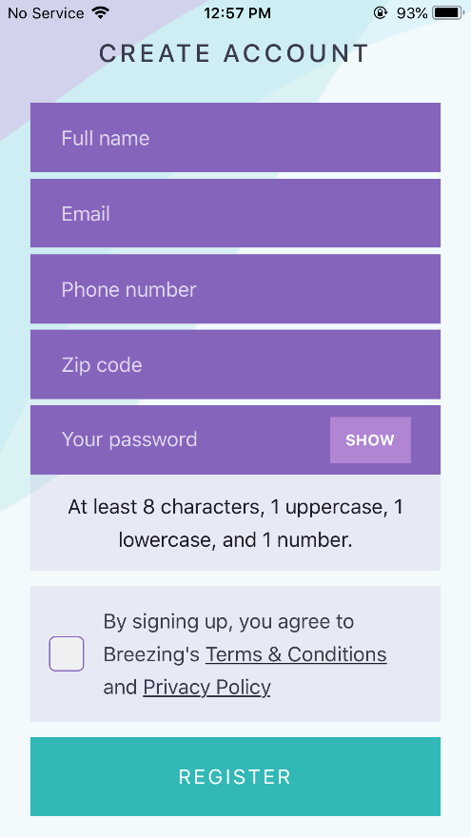

SIGNING IN TO THE ACCOUNT:
- For a returning user, use the credentials used to create the account, to sign in.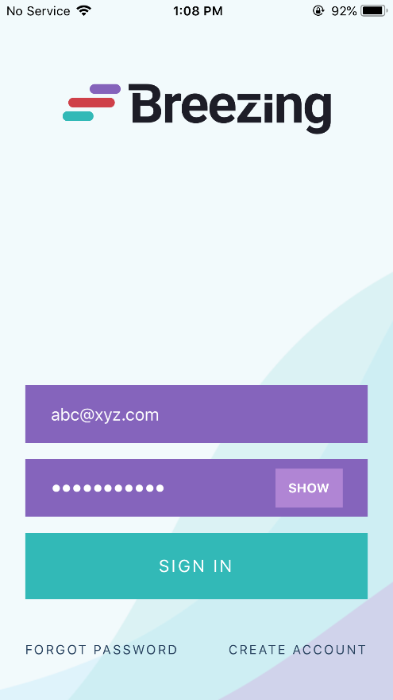
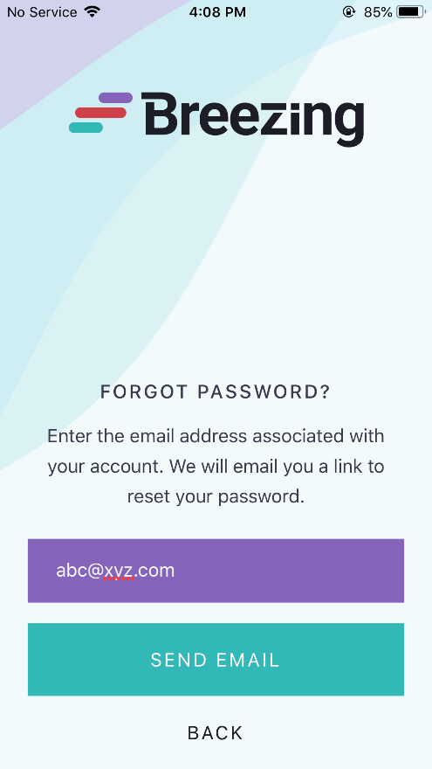
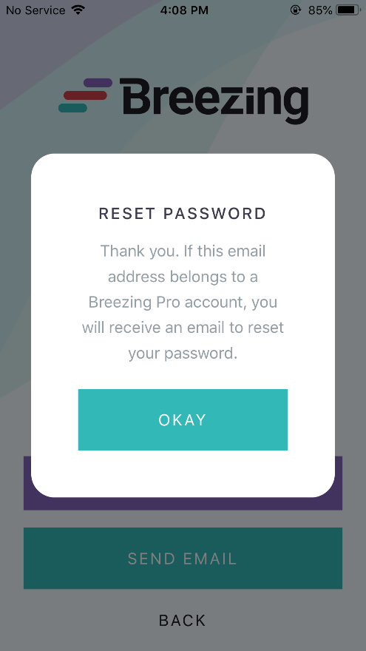
- Use the “Forgot Password” option if user forgets the password or to change the password. A link to change the password will be generated and sent to the email address provided (which should be same as the one used to create the account).

ADDING PATIENTS:
- Once the user has signed into the account, patient information will be displayed on the screen. If the user is signing into the account for the first time or has not yet added a patient, “No patients added yet” message will be displayed, and the user can add new patients.
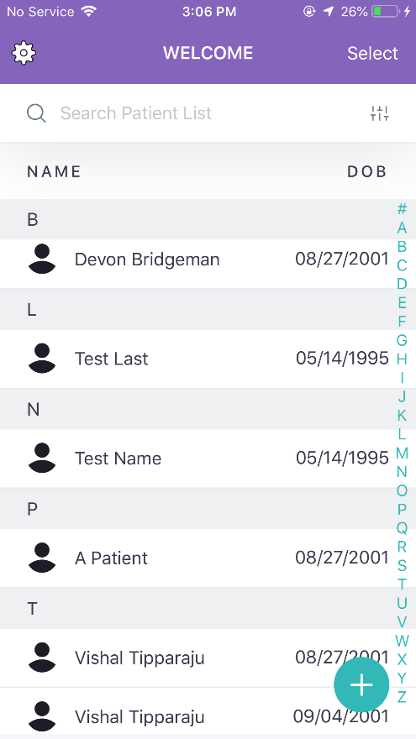
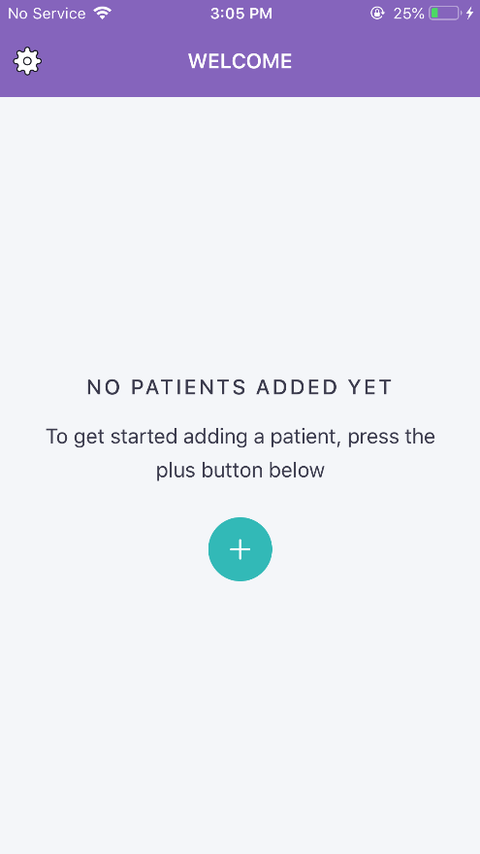

- To add new patients, select the “+” icon and fill the patient details and select “Continue”. The user can also add multiple patients, associated to the same account.

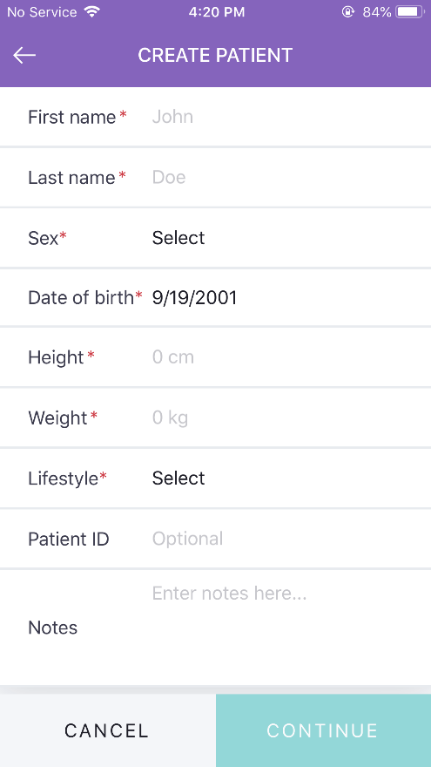

- To delete or export a patient’s record, select the “Select” option from the main menu and choose the desired option.
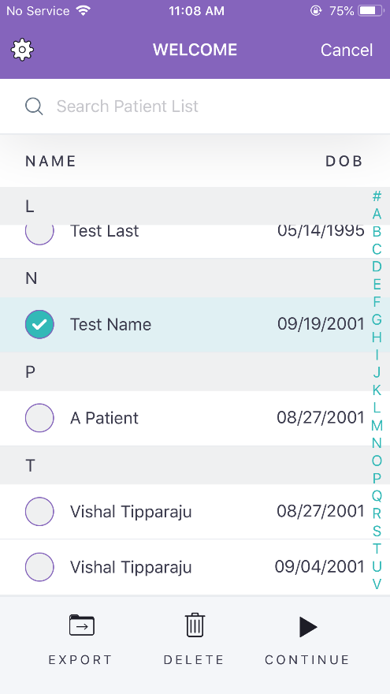

COMPARE MEASUREMENTS

To compare measurement values over the history of the patient, select the Compare button below the Test History Diagram, select the measurements wished to be displayed, and then select Compare. The color-coded measurements will be displayed across time.
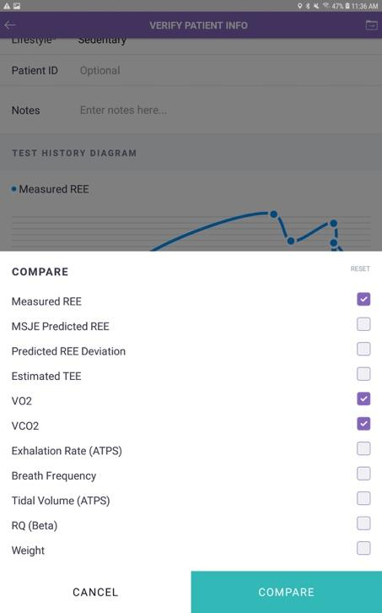
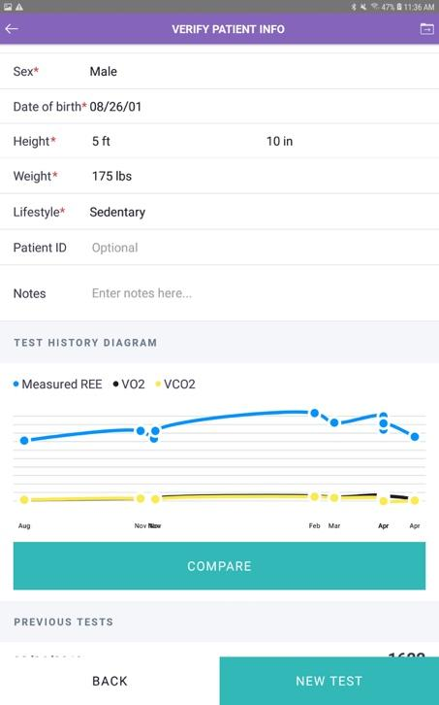
VIEW PREVIOUS TESTS

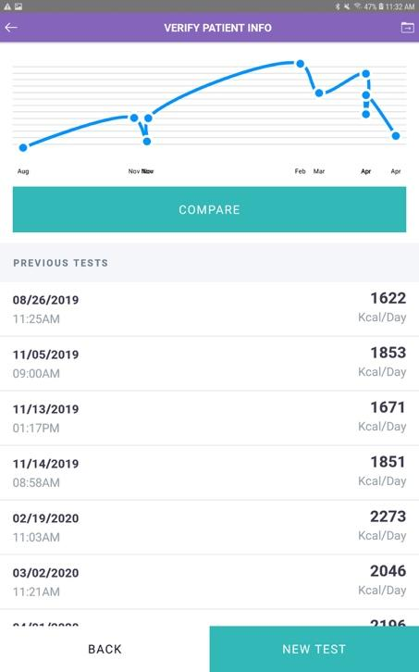
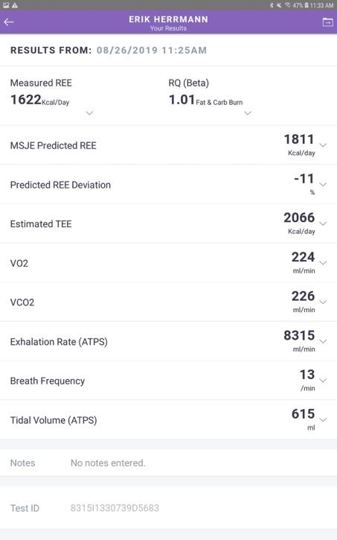
Once you have logged into the app, scroll downward until you see the Previous Tests section. Select a date/time record of interest and review the measurements. Either tap the Folder in the top right of the banner to export the measurements or the Back arrow in the top left of the banner.

EXPORT TEST DATA

From within the patient’s record, tap the folder icon in the top right banner. Then select the option to export the Most Recent test or the patient’s Entire History. The Comma Separated Variable (CSV) file will be emailed to the address used for the account login.

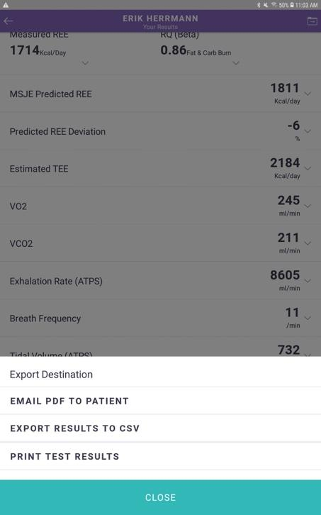
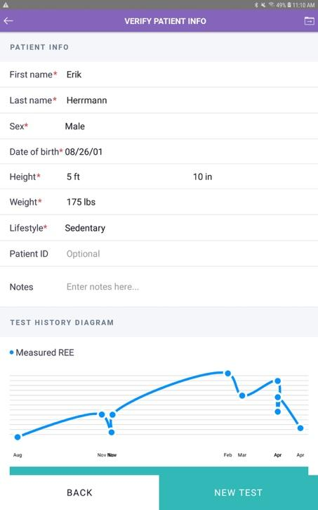
SETTINGS:

To go the Settings menu, select the gear-like “Settings icon” from the top left corner of the main menu. User is provided with various options to enhance the experience.

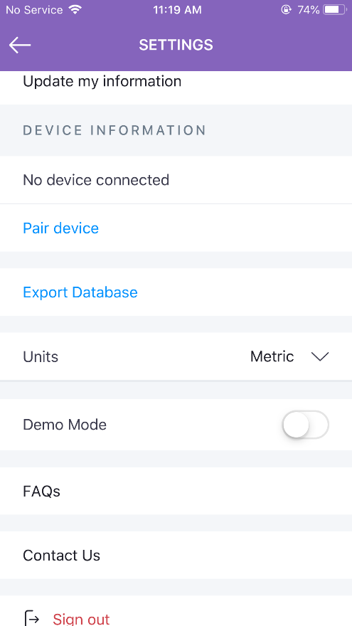
User can update the account information from the settings menu, under the “Update my information” option

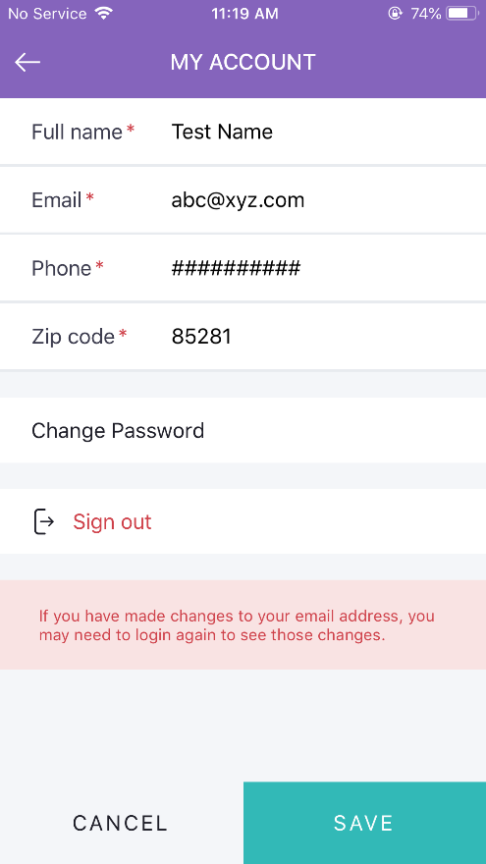
To report any issue with application or the Breezing ProTM device, the user can send a message using the “Contact Us” option from the settings menu.

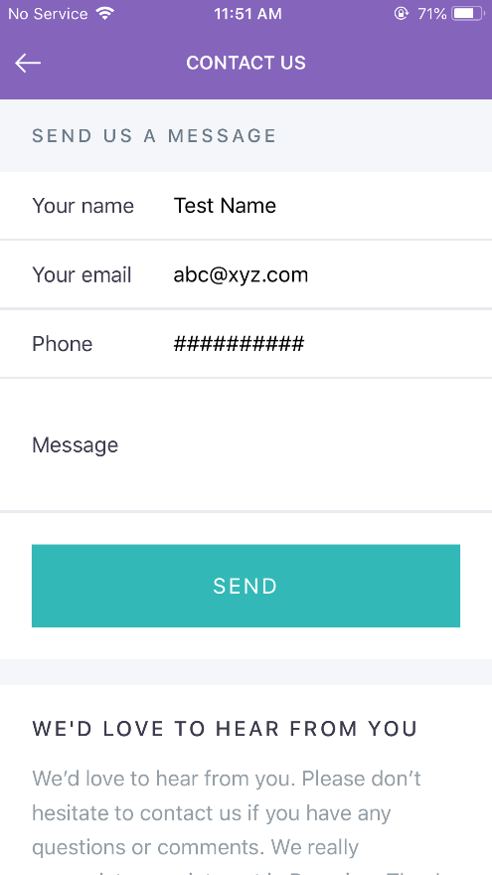

The user’s patient database can be exported by selecting Export Database. The Comma Separated Variable (CSV) file will be emailed to the address used for the account login.

FIRMWARE UPDATE

Breezing MedTM is designed to be able to update its firmware via the app. If there is new firmware released, the app will remind the user to update the firmware. The user can follow the step-by-step instruction in the app to update the firmware. In summary, the steps for firmware update are:
      - Press and hold the Power Button on the Breezing MedTM
      - Keeping the power button pushed in, press and release quickly the reset button, using a fine instrument such as an SD card remover or paperclip
      - Keep the power button until the logo displayed on the Breezing MedTM display changes from a “B” to a “↓” symbol

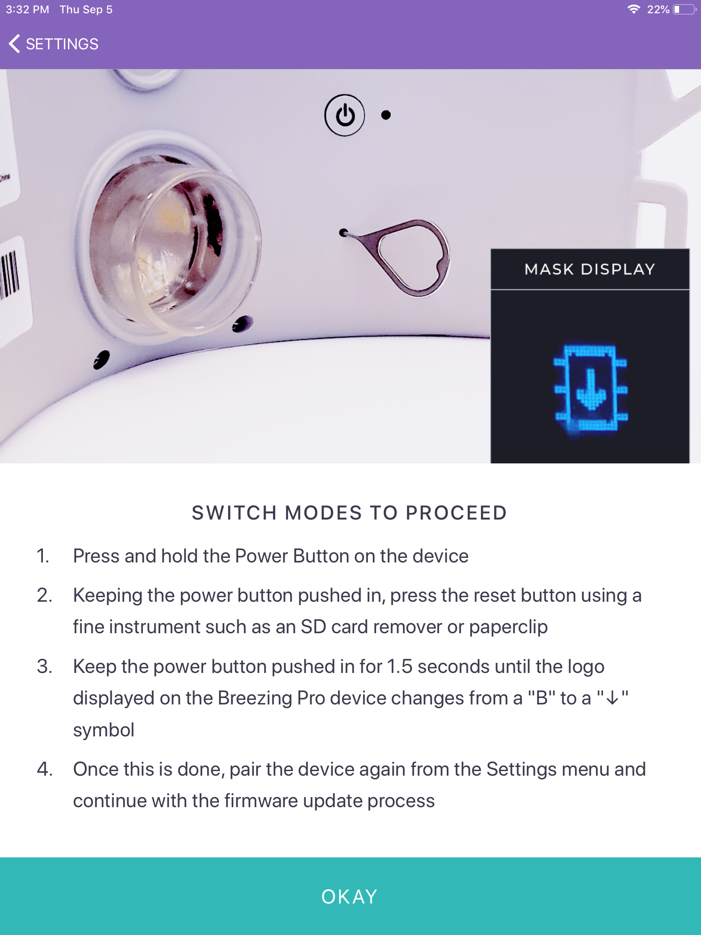

4) Once this is done, prepare to click and execute the following consecutive actions from Settings:
“Pair device”
“Update firmware”
“Download and install”

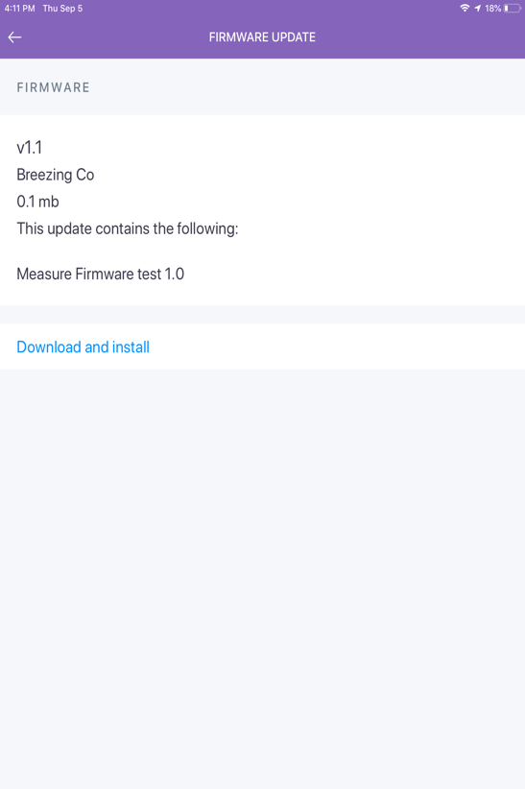
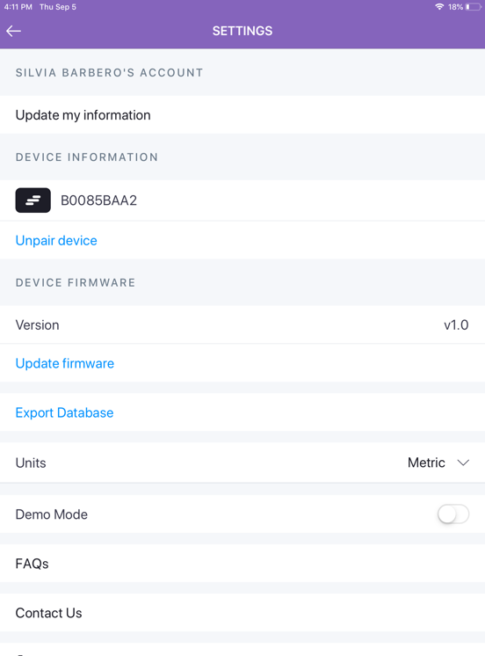
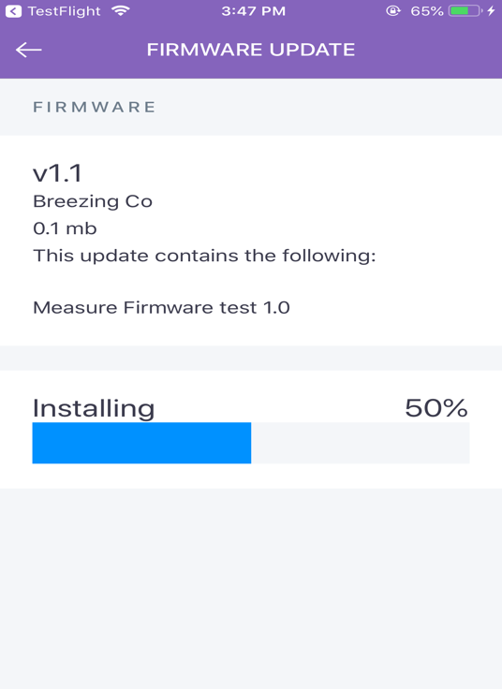
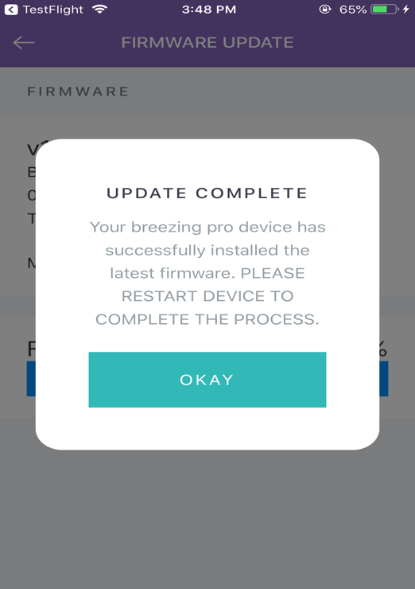

5) After the installation of the new firmware is complete, the user will be prompted to restart (turn off/on) Breezing MedTM unit to switch it back to measurement mode.

CHARGING

It is best practice to charge the Breezing MedTM overnight to ensure it is fully charged and ready to use the following day. In the event the battery becomes depleted, a yellow LED on the bottom of the Breezing MedTM will illuminate. Using the charger and cable supplied with your device, ensuring the device is turned off, plug the USB micro-B connector into the device’s port next to the LED’s. The white LED will illuminate indicating the battery is being charged. When the white LED turns off, the Breezing MedTM is fully charged and ready for use.

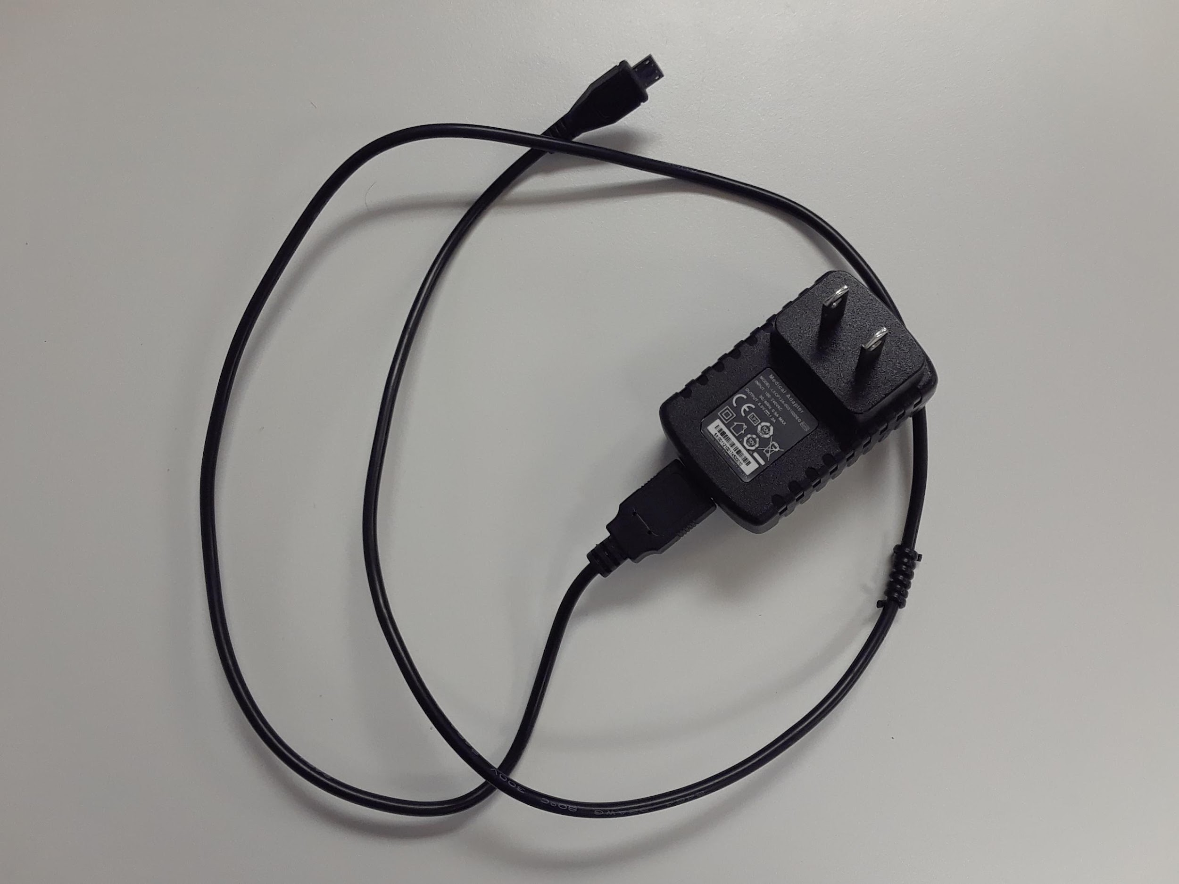
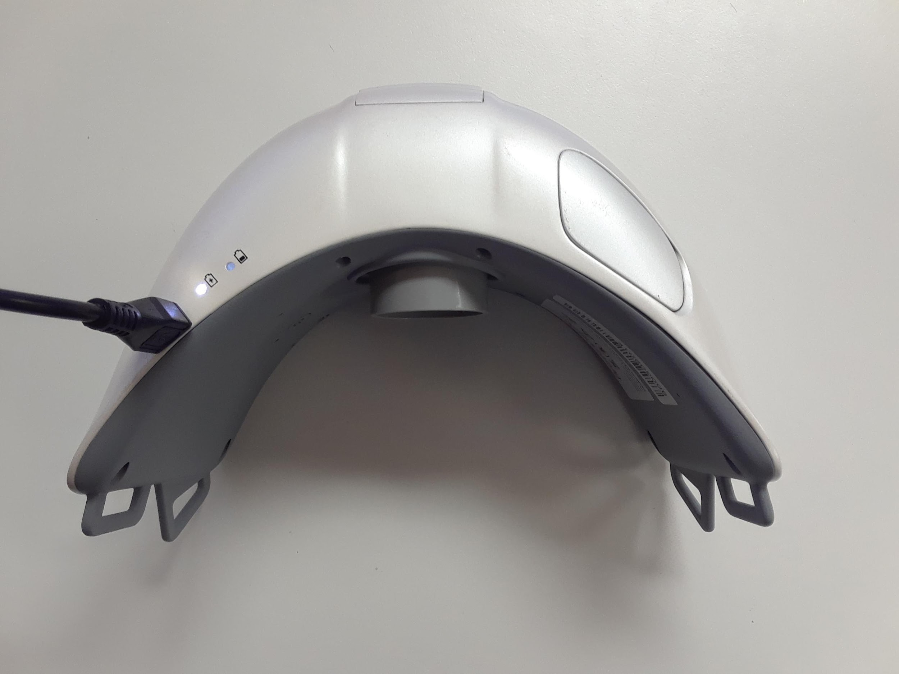
ALARMS, WARNINGS and NOTIFICATIONS
 | ALARM,  WARNING, or  NOTIFICATION | DESCRIPTION
Breezing Med
1 | 1 second tone and blue LED | Speaker generates tone and LED illuminates when the Breezing MedTM has become operational.
2 | Green LED | Green LED illuminates when measurements are being made.
3 | Low Battery | The yellow LED on the bottom of the Med will illuminate when the battery is approaching depletion. Cease use of the Breezing MedTM, plug in and recharge the battery.
4 | Battery Charged | The white LED on the bottom of the Breezing MedTM will illuminate when the battery is being charged. When it is no longer lit, the Breezing MedTM is fully charged, can be unplugged from the charger and used for measurement.
Breezing Mobile Device App
1 | Stop Test? | Selection of the Cancel button will create a popup to confirm the user wishes to cease action.
2 | No Device Found | Message generated when a Bluetooth pairing between the Breezing MedTM and the mobile device is unsuccessful.
3 | Sensor Used | The sensor either has been out of the pouch too long or has been used in a previous measurement.
4 | No Sensor Detected | A new sensor was not inserted into the Breezing MedTM.
5 | Sensor Flipped | The sensor was incorrectly inserted into the Breezing MedTM.

GLOSSARY
 | Breezing Med Parameter | Description
 | Measured REE | The Resting Energy Expenditure measured by the Breezing MedTM. Units are kcal/day.
 | RQ (Beta) | Respiration Quotient is the ratio of the volume of carbon dioxide produced to that of oxygen consumed and is used to determine how much energy is generated from carbohydrates vs. fats. This is a unitless value.
 | MSJE Predicted REE | The Resting Energy Expenditure predicted by the Mifflin-St. Jeor Equation. Units are kcal/day.
 | Predicted REE Deviation | The difference between the Measured REE and Predicted REE. Units are in percentage.
 | Estimated TEE | The Estimated Total Energy Expenditure includes all other uses of energy in addition to the REE. Units are in kcal/day.
 | VO2 | The average consumption rate of oxygen during the measurement duration. Units are in mL/min.
 | VCO2 | The average production rate of carbon dioxide during the measurement duration. Units are in mL/min.
 | Exhalation Rate (ATPS) | The average rate of exhalation as measured under Ambient Temperature and Pressure, Saturated conditions. Units are in mL/min.
 | Breath Frequency | The average number of breaths per minute. Units are breaths/min.
 | Tidal Volume (ATPS) | The average volume of a breath. Units are in mL.
 | Notes | Space for the user to enter notes regarding the patient or measurement.
 | Test ID | A unique identifier associated with the patient’s measurement record.

Breezing Med Device, Mask and Headstrap Cleaning and Disinfection Procedure

General Note
This procedure has been designed based on a deep review of literature¹⁻⁵, and further optimized based on more recent knowledge related to COVID-19⁶ and related viruses^{2,3}.

General Recommendation
This procedure is applicable to Breezing Pro/MedTM, herein referred to as the Breezing device, masks and headstraps.

Cleaning and Disinfection of Breezing Med Device
Cleaning and disinfection must be performed before every new patient, or if the device is deemed uncleanable, per the facility’s risk assessment. The cleaning and disinfection process can be done at room temperature.
Caution: The Breezing device cannot be immersed in liquid. Doing so will damage the electronic components/battery or may cause tubing blockage rendering the device unusable.

Cleaning and Disinfection Procedure
It is recommended to wear personal protection equipment such as eyeglasses, goggles or a face shield, as well as long sleeves and nitrile gloves when cleaning the Breezing device. Defer to any additional guidelines in place at your facility.
- Mix the cleaning solution with Enzol (or equivalent enzymatic cleaner) per the manufacturer’s instructions.

Cleaning Procedure of the device:
- Apply the Enzol solution over the external surfaces of the device with a clean solution-soaked cloth, ensuring all surfaces are thoroughly moistened. Then, scrub the wet surface vigorously and firmly using a cloth and a soft-bristled brush for a minimum of 30 seconds to ensure the removal of all debris. Reapply the Enzol solution for 2 minutes. This includes: the internal and external case, display window, sensor cap (top and edges), enclosure mating seams, and power button.
Tight spaces, such as the recessed screws on the back of the device, may require the direct application of the Enzol solution into them using a polyethylene swab while holding the device surface parallel to the floor and allowing the solution to flow into the device. If wipes are used instead (please see below for more information), make sure all the tight spaces are reached by pressing the wipes adequately to allow the cleaning agent to be forced out and soak the tight spaces. If wipes become too dry and not enough cleaning agent comes out, please use a fresh wipe.

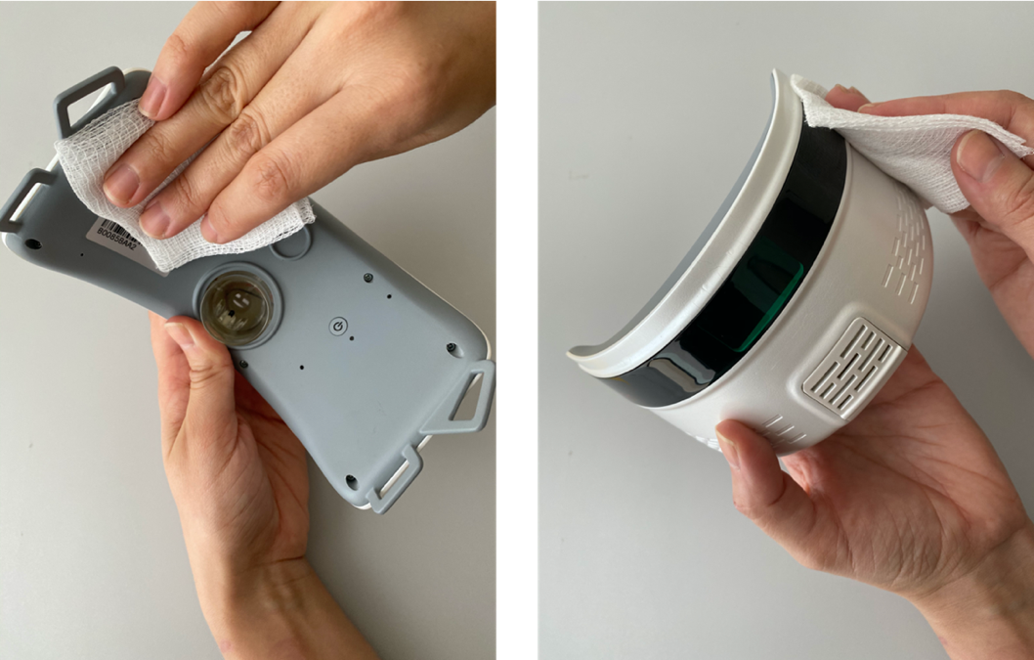

- After the cleaning, thoroughly wipe the device surface with a cloth made wet with clean water, ensuring all solution and residue are removed. Then, apply a dry cloth to dry the surface.
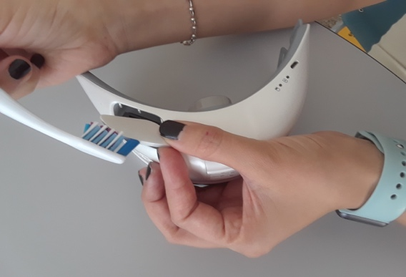
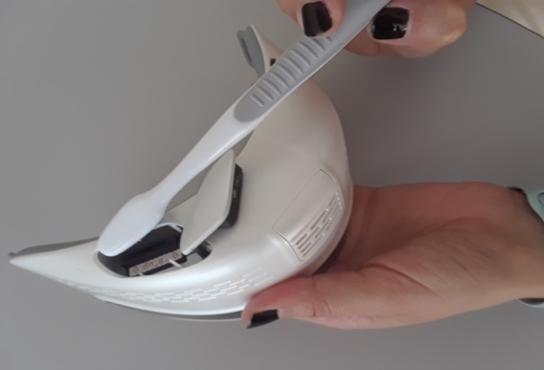
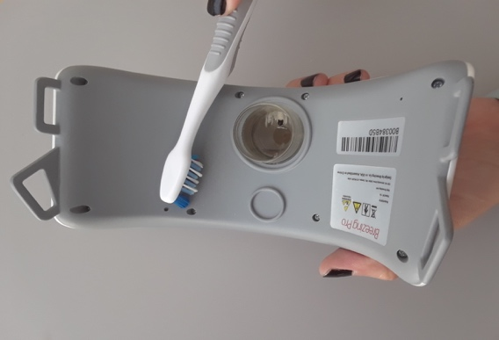
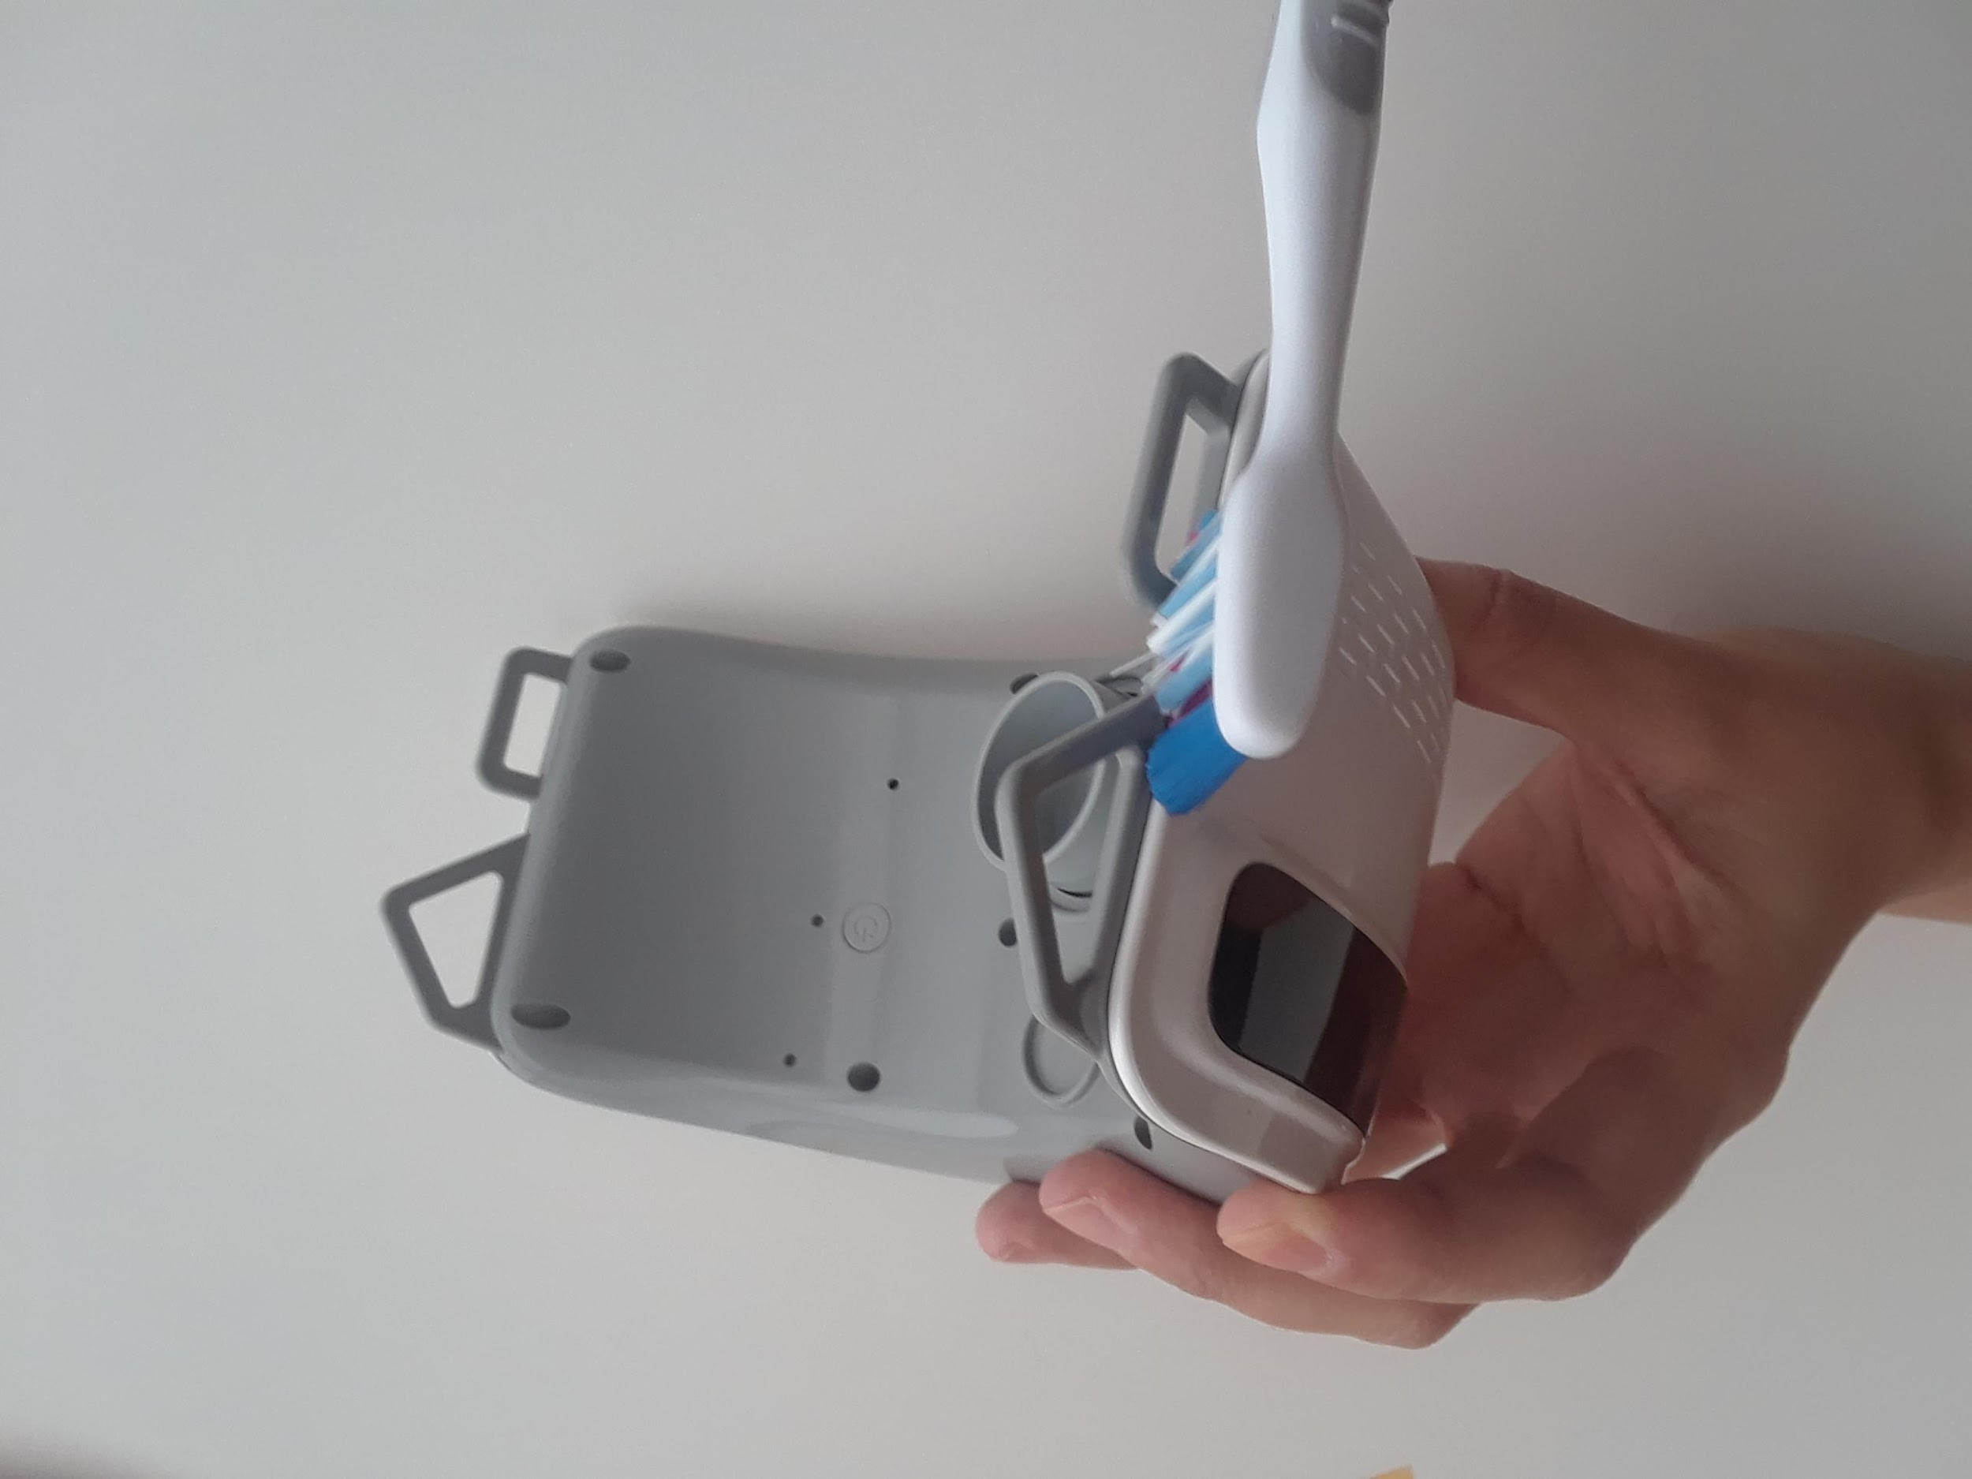
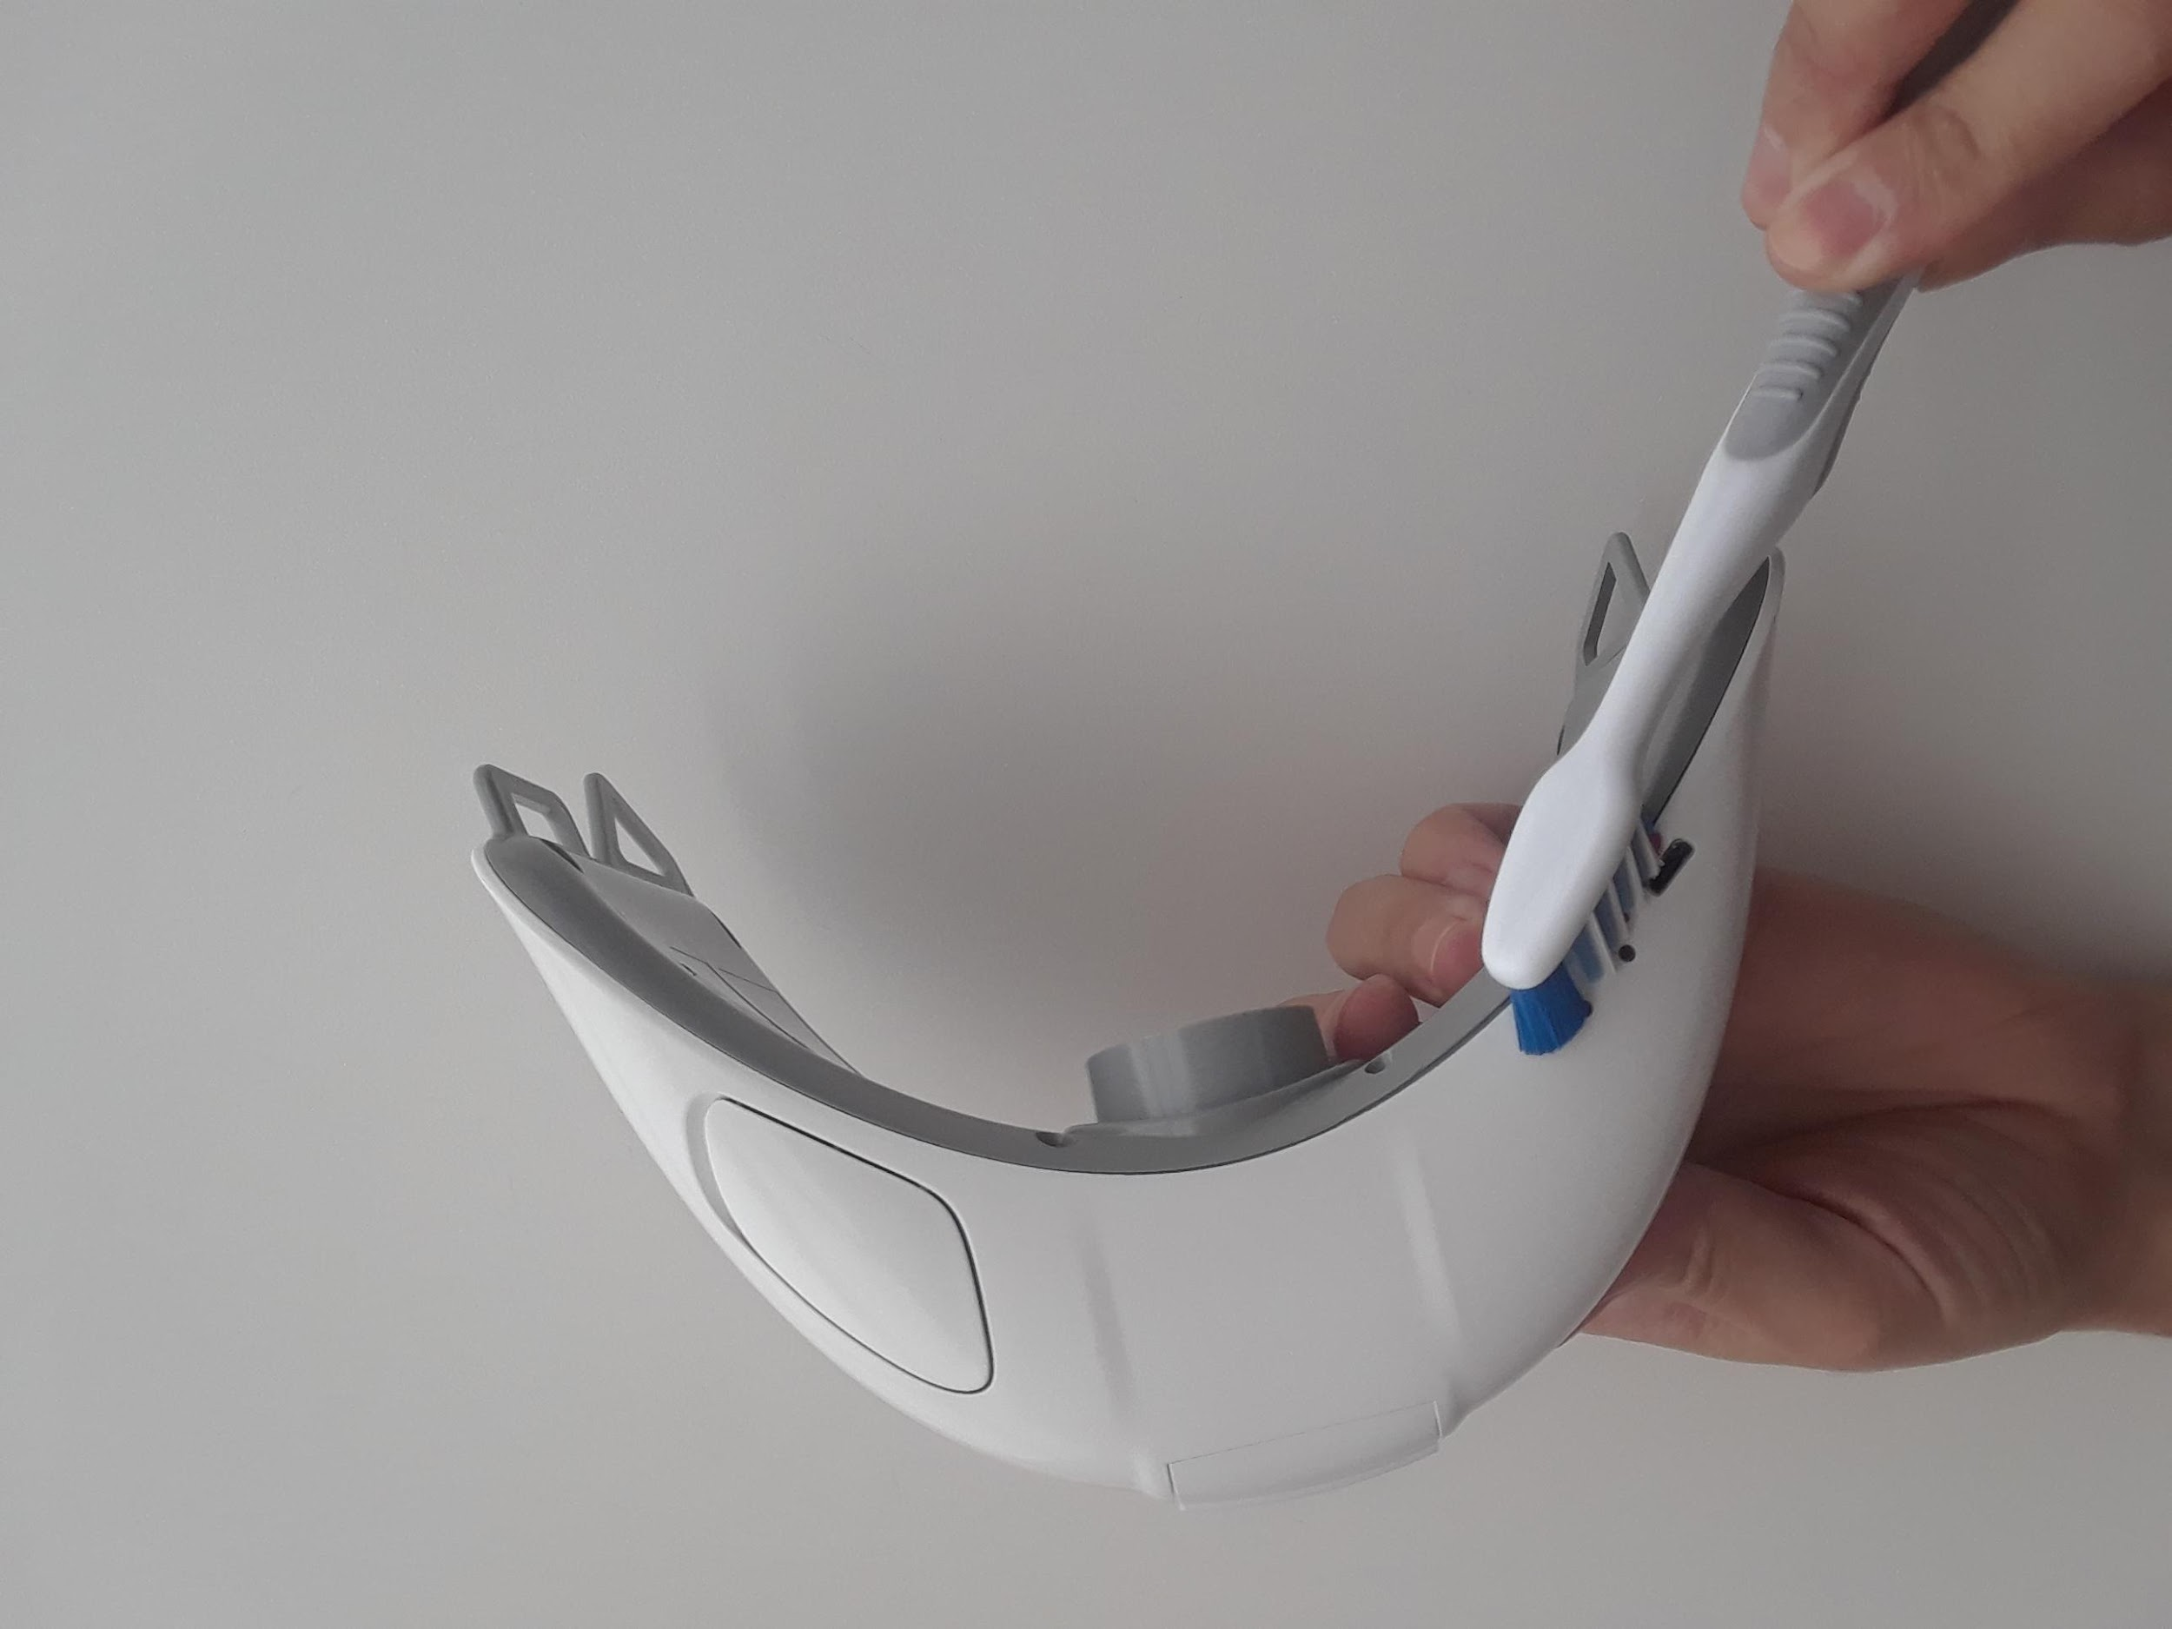
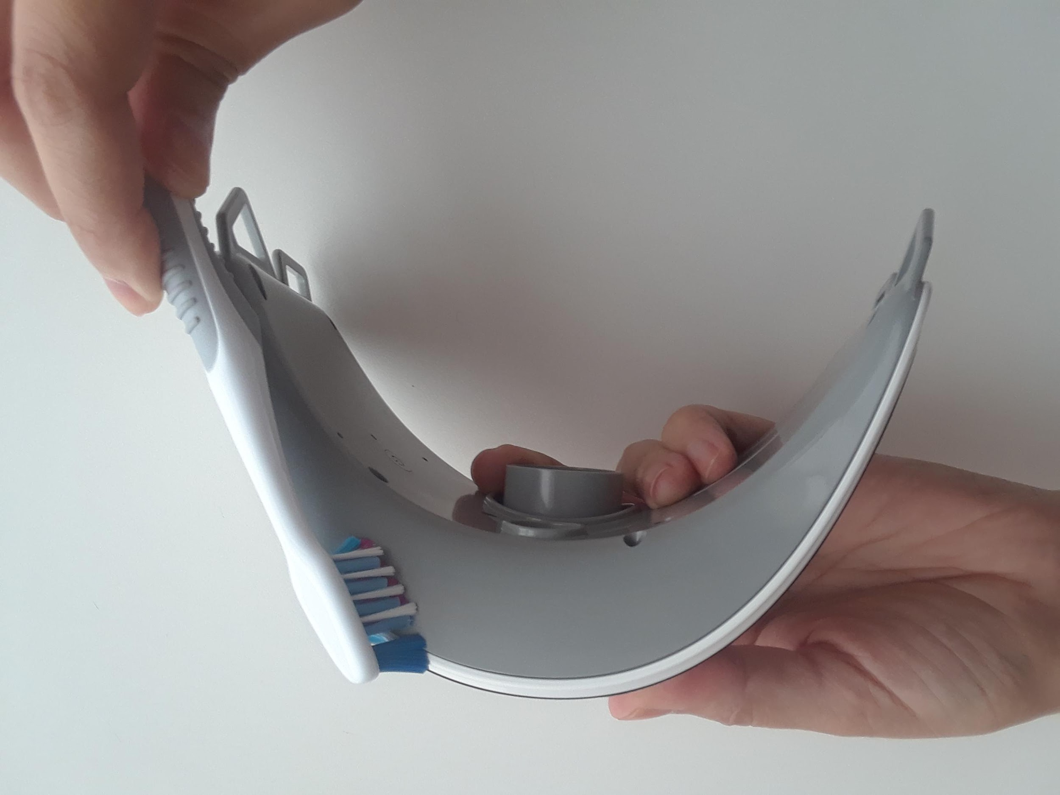

NOTE: please make sure no solution leaks inside the device. This may damage internal device components.
Cleaning Procedure of the grate and air channel:

- Remove the grate at the front of the device that covers the air channel by pulling it firmly downward (i.e. away from the display).

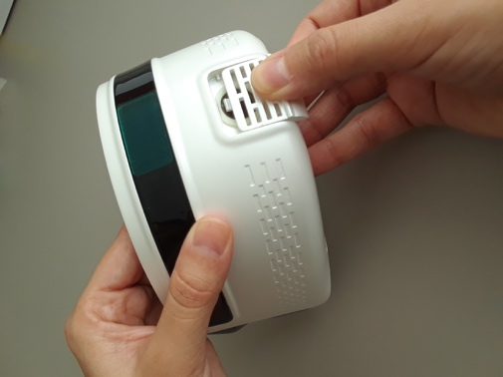

Removing the grate
- Scrub the grate using a soft-bristled brush for 30 seconds and polyethylene swab to ensure the removal of all debris. Let the grate soaked for 2 minutes. Complete the grate cleaning by rinsing in clean water and then drying with a clean cloth.
- Using an Enzol solution wetted cloth and polyethylene swab, wipe the solution over the surface of the air channel; this includes the interior as well as the exterior surface that mates with the disposable mask. Allow the solution to react for 2 minutes. After the cleaning, thoroughly wipe the device surface with a cloth made wet with clean water, ensuring all solution and residue are removed. Then, apply a dry cloth to dry the surface.
Take care not to allow excessive solution pool in the air channel as small ports exist that if blocked could prevent the proper functionality of the device.
- Reattach the grate to the device by aligning in the cavity and sliding upward until a click is heard.
- User is to repeat this cleaning procedure until a visually clean endpoint has been reached.

After cleaning with the wipes, use another wipe to remove excess cleaning liquid and let the surface dry up.

NOTE: please make sure no solution leaks inside the device. This may damage internal device components.

Cleaning grate and air channel
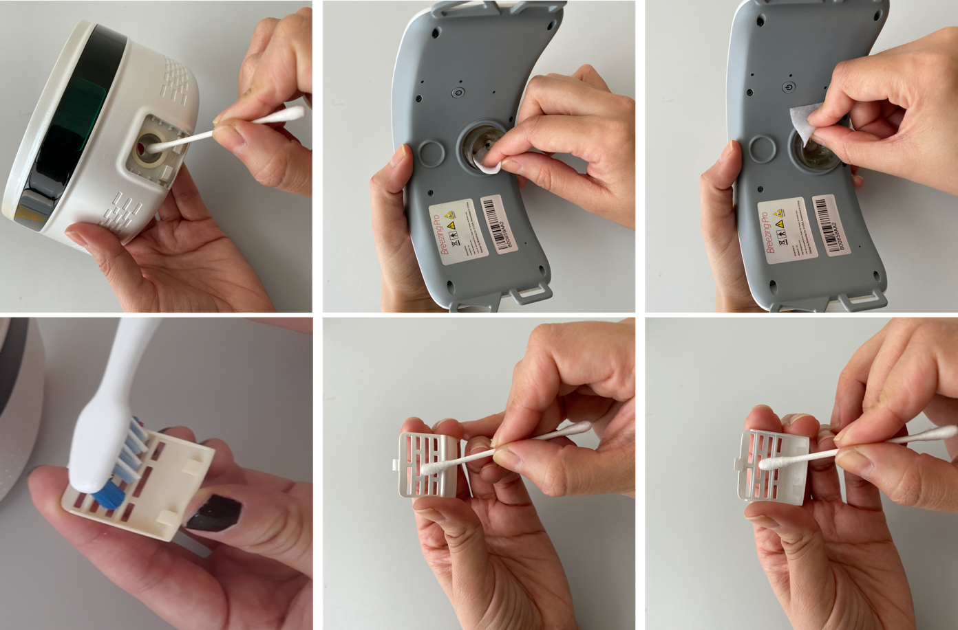

Disinfection of the external device pieces:

- Use a 70% isopropyl alcohol (IPA) to spray all over the exposed areas of the device, allowing for a minimum of 60 seconds to ensure the soaking of all areas. Afterward, scrub the surface of the Breezing device vigorously and firmly using a soft-bristled brush and a cloth soaked in 70% IPA. Ensure all external pieces of the Breezing device are sprayed with IPS, including (but not limited to): the front and rear case, display window, sensor cap, sensor cavity edges, and power button. Ensure the entire surface is coated with 70% IPA, allow some IPA to flow into the screw recesses using an IPA-soaked polyethylene swab.
Note: IPA should remain on the device surface for at least 60 seconds to assure disinfection, and the device should be fully dried out before any new measurement.
- Open the sensor cap and ensure the edges of the cap and the outer edges of the cavity are wiped with the cloth soaked in 70% IPA. Ensure the sensor cap edges and sensor cavity edges are wiped thoroughly. Avoid any liquid from going into the sensor slot.

NOTE: please make sure no solution leaks inside the device. This may damage internal device components.

Note: IPA should remain on the device surface for at least 60 seconds to assure disinfection, and the device should be fully dry out before any new measurement.
Disinfecting external device pieces

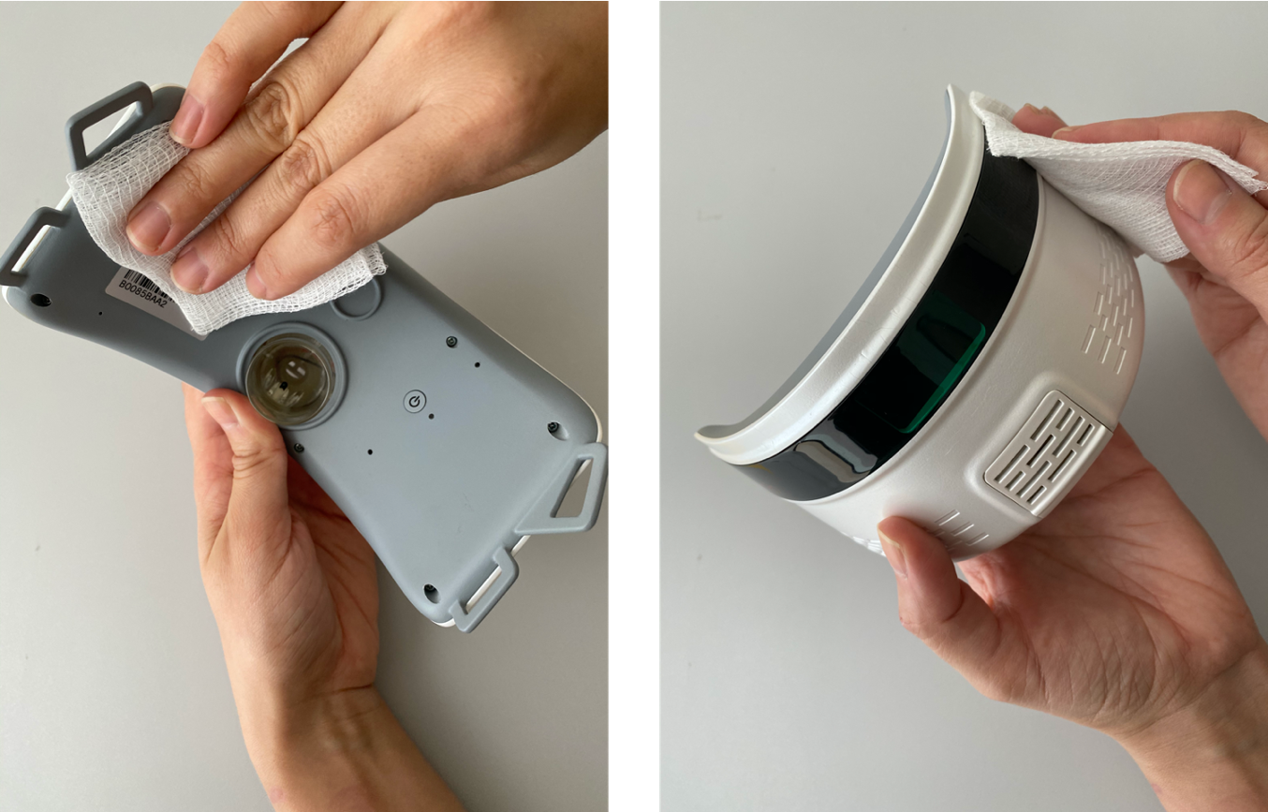
- Disinfection of the air channel and grate: grate is to be immersed in the 70% IPA solution for at least 60 seconds and allowed to thoroughly dry. Afterward, use a 70% IPA-soaked polyethylene swab to wipe firmly and thoroughly the entire air channel and grate. Ensure the entire surface has been soaked with 70% IPA.
Allow the air channel to thoroughly dry in clean air.

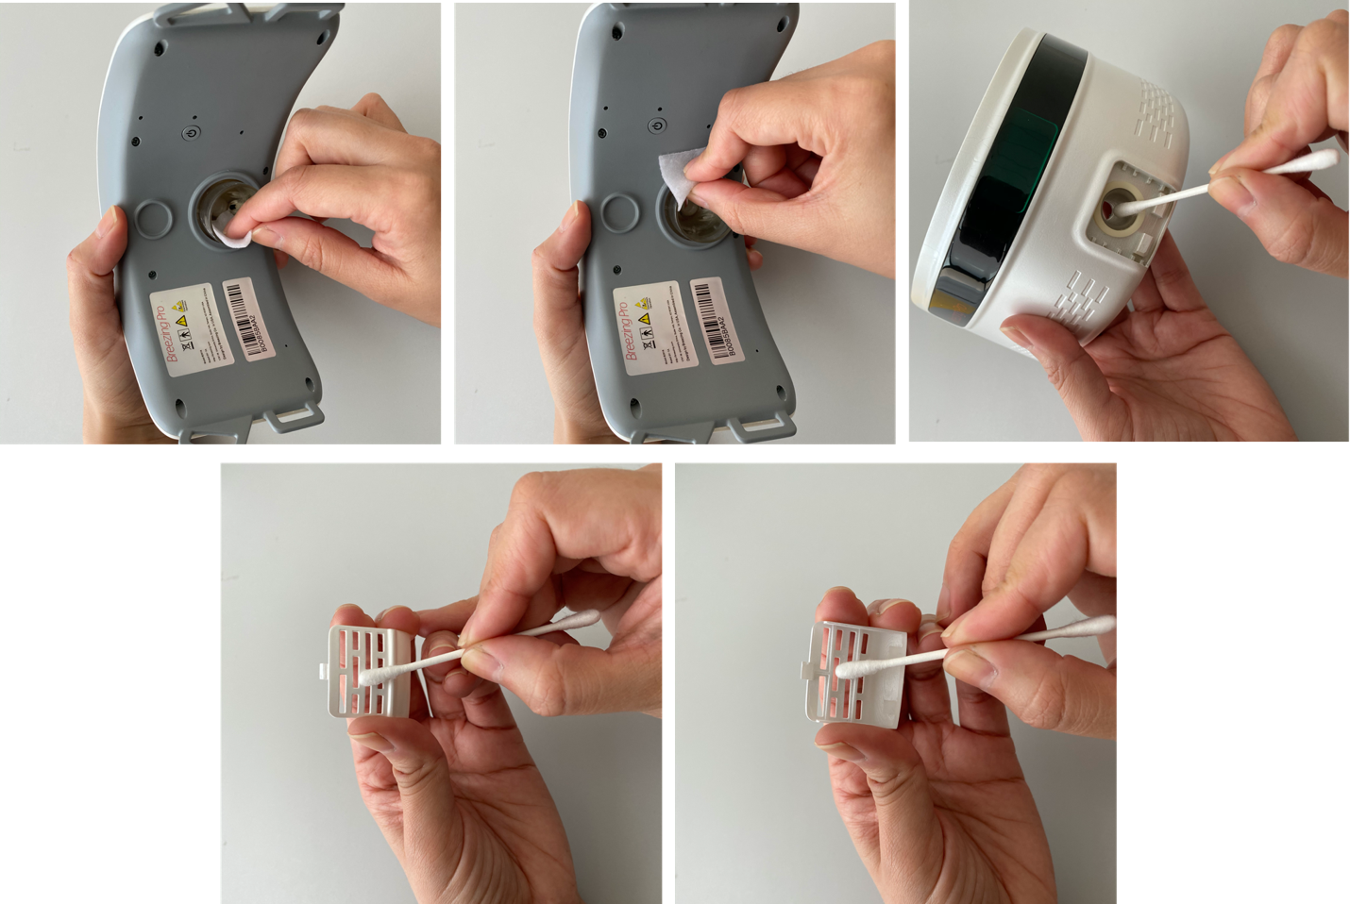
NOTE: please make sure no solution leaks inside the device. This may damage internal device components.
Disinfecting air channel and grate

- Replace the grate by orienting it over the opening and firmly push upward (i.e. toward the display) until a click is heard and the grate is held in place.

Re-installing the grate
- Close the sensor cap. The Breezing device is ready for use.

Caution:
Though every measure is taken to ensure all surfaces of the device are clean and disinfected, there exists the potential that material remains. The user must follow the contraindications, utilize new one-time use accessories, and use their training and facility’s guidelines to avoid harming the patient.
Always keep the IPA solution away from the face or exposed skin. Do not inhale any of the vapors and wash immediately with running water if liquid comes in contact with the skin.
Avoid scratching the device surface with sharp tools during the cleaning and disinfection process.
Avoid pulling or bending the spherical component located in the air channel on the mask-side part of the constriction. If this component is damaged, contact Breezing Co.

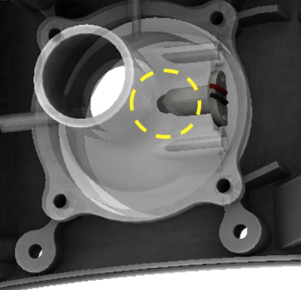
Contraindications
Be aware the following conditions are contraindicated with respect to the maintenance of a clean and disinfected device:
- The device is not to be used if any respiratory impediments, illnesses, or chronic conditions are present.
The device is not to be used if any infectious agents are present.

Cleaning and Disinfection of Accessories: Silicone Masks and Headstraps
Silicone masks and headstraps should be thoroughly cleaned and disinfected to ensure patient safety and to reduce risk of infection.

Cleaning and Disinfection Procedure
Note: Wear all personal protection equipment such as safety goggles or a face shield, as well as protective arm sleeves and nitrile gloves when cleaning the masks and headstraps.

Preparation before cleaning and disinfection
Freshly prepare a total of two (2) baths as follows:
- Bath 1: A 10% bleach solution bath.
  - Suggested preparation for cleaning and disinfecting 5 silicone masks and 5 straps: 500 mL of concentrated sodium hypochlorite (house cleaning bleach) added to 4500 mL of distilled water. Stir the solutions to ensure homogenous mixing before use.
- Bath 2: An Enzol solution bath.
  - Suggested preparation for cleaning and disinfecting 5 silicone masks and 5 straps: 30 mL of pure Enzol in 4L of distilled water. Stir the solutions to ensure homogenous mixing before use.

Procedure for cleaning and disinfection

Prior to cleaning and disinfection, wash masks and headstraps in running tap water to remove foreign material.
- Submerse the silicone masks and headstraps in 10% diluted bleach solution for 20 minutes (bath 1). Stir to assure contact of all surfaces with the solution, and make sure that the silicone masks and straps are completely immersed in the solution.
- Take the silicon masks and headstraps from the bleach solution (bath 1) and place them under running water for 5 minutes. Remove the masks and headstraps from the disinfectant bleach solution thoroughly with the aid of properly glove-protected hands. Then, immerse the silicon masks and straps in 2 liters of distilled water and gently shake them to remove potential bleach residues for at least 5 minutes.
- Immerse the silicone masks and headstraps in the diluted Enzol solution bath (bath 2) for 20 minutes. Make sure that the silicone masks and straps are completely immersed in the solution, and thoroughly stirring is provided to the silicone masks and headstraps to ensure cleaning of contaminating materials. Headstraps should be mechanically washed (e.g. hand washed) if visible stains are observed until stains are removed.
- Take the silicon masks and straps from the Enzol solution bath and place them under running water for 5 minutes. Remove the masks and headstraps from the cleaning Enzol solution thoroughly with the aid of properly glove-protected hands. Then, immerse the silicon masks and straps in 2 liters of distilled water and gently shake them to remove potential Enzol solution residues for at least 5 minutes.
- Place the disinfected and cleaned silicone masks and headstraps on a clean and disinfected surface with a clean environment to dry out.
- Ensure silicone masks and straps are thoroughly dried prior to use or storage to inhibit the growth of waterborne organisms. It is recommended that a sterile wipe be used to dry the them and store them d in new cleaned and pathogen-free plastic bags.

Silicone mask and strap inspection before use
Visually inspect silicone masks and headstraps after cleaning and disinfection to ensure that they are ready for reuse.
Cleanliness of the silicone masks and straps must be assessed. Visually inspect for any indications of remaining disinfectant residue as well as organic material or persistent stains. If any indication of the previous mentioned contaminants is observed, repeat the entire cleaning and disinfection process. If stains have not been removed, the silicone mask or strap must be disposed of and replaced with a new or properly cleaned and disinfected.
Observe for any defects in the silicone masks and straps. Test appropriate function of exhalation and inhalation valves and sealing of the silicone on the user’s face. Any mal-function, deformation or tears in the silicon masks or headstraps upon inspection should be considered defective. Defective parts must be disposed of and replaced.
The process mentioned above has rendered unaltered functional quality of 5 silicone masks and 5 headstraps when applied for 100 cycles in Breezing laboratories.

References
- Breezing Co. will provide a Cleaning and Disinfection Validation report upon request (info@breezing.com).
- William A. Rutala, Ph.D., M.P.H., David J. Weber, M.D., M.P.H., and the Healthcare Infection Control Practices Advisory Committee (HICPAC), Guideline for Disinfection and Sterilization in Healthcare Facilities, 2008 Update: May 2019
Accessible version: https://www.cdc.gov/infectioncontrol/guidelines/disinfection/
- Andrej Trampuz, MD, and Andreas F. Widmer, MD, MS, Hand Hygiene: A Frequently Missed Lifesaving Opportunity During Patient Care, Mayo Clin Proc, January 2004, Vol 79:109-116.
- Reprocessing Medical Devices in Health Care Settings: Validation Methods and Labeling
Guidance for Industry and Food and Drug Administration Staff. May 2, 2011.
Labeling - Regulatory Requirements for Medical Devices (FDA 89-4203)
- AAMI TIR30: 2011/(R)2016 A compendium of processes, materials, test methods, and acceptance criteria for cleaning reusable medical devices
- Annika Kratzel, et al., Efficient inactivation of SARS-CoV-2 by WHO-recommended hand rub formulations and alcohols, bioRxiv preprint, doi: March 10, 2020
Accessible version: https://www.biorxiv.org/content/10.1101/2020.03.10.986711v1.full.pdf
- https://www.cisa.gov/sites/default/files/publications/Quaternary%2520Ammonium%2520Disinfectant%2520Alternatives%2520Fact%2520Sheet%2520_FINAL_508.pdf


Breezing Med, Instructions For Use
D-310-IFU
Rev G

Revision History
REV | DATE | INITIATED/  CHANGED BY | CHANGE DESCRIPTION
A | 11/25/2019 | E. Herrmann | Initial release
B | 12/2/2019 | E. Herrmann | Updated Pro name to Med.
B | 12/17/2019 | E. Herrmann | Rev letter typo corrected.
C | 1/2/2020 | E. Herrmann | Updated operating values. General formatting.
D | 5/11/2020 | E. Herrmann | Updated CL/DI protocol, app/device instructions, Added backflow test results. Format clean-up
E | 9/17/2020 | E. Herrmann | Added repeat cleaning step at end of cleaning procedure.
F | 12/18/2023 | E. Forzani | Adding cleaning and disinfection of masks and headstraps.
G | 2/12/2025 | E. Forzani | Adding Specification Table.

APPROVALS
(Hard copy signatures or electronic signatures within Quality Management System)
President: Erica Forzani | QMS Representative: Jimena Mora | CEO: Shuang Huang
Date: 2/12/2025 | Date: 2/12/2025 | Date: 2/12/2025

